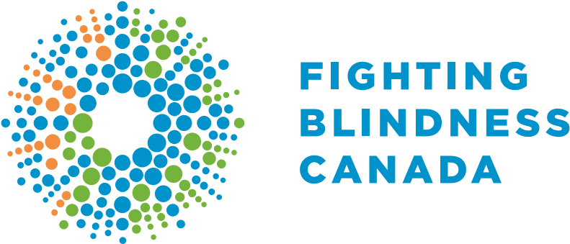
2018
IMPACT
REPORT
LOOK BENEATH THE SURFACE TO LEARN HOW WE ARE TACKLING BLINDNESS.
This report highlights Foundation Fighting Blindness-funded research to PRESERVE VISION and RESTORE SIGHT; showcases outcomes from our programs that EDUCATE patients, families, and young leaders in our community; and demonstrates that we continue to ADVOCATE about the issues that matter most.

PRESERVE VISION
Many blinding eye diseases involve the progressive loss of vision. These Foundation Fighting Blindness (FFB) discoveries will help stop vision loss in its tracks.

❚ UNDERSTANDING GENETIC BLINDNESS
In 2018, FFB-funded scientists discovered 21 new blindness causing mutations. After decades of research, gene therapy to treat blindness is now a reality. Although the first approved gene therapy is only available in the USA, this paradigm-shifting development has dramatically accelerated the race to treat genetic eye diseases. Diagnosis is the first step toward treatment – that’s why this new knowledge provides an essential foundation to understand and ultimately treat genetic blindness. ❚ COMBINING GENE THERAPY & STEM CELL THERAPY
Treating wet age-related macular degeneration, the most common blinding eye disease in people over the age of 55, involves regular injections of an “anti-VEGF drug” into the eye. Dr. Andras Nagy is combining stem cell therapy and gene therapy to deliver an anti-VEGF treatment with a one-shot stem cell transplantation approach. In 2018, he generated promising evidence that shows stem cells can be engineered to safely and effectively deliver an anti-VEGF drug to diseased eyes. ❚ PROTECTING CELLS TO PRESERVE & RESTORE VISION
The FFB’s Restore Vision 20/20 Initiative funds research with the greatest potential to progress toward the clinic. In 2018, we announced Dr. Philippe Monnier as the first recipient of this award! He is developing a sight-saving drug that aims to stop vision loss by protecting precious vision cells.

RESTORE SIGHT
Blindness happens when important vision cells are damaged or dying. These FFB discoveries will help to restore vision by replacing or fixing these precious cells.

❚ MAKING EFFECTIVE STEM CELL THERAPIES
Multiple FFB-funded scientists continued to develop innovative methods to generate photoreceptors, the eye’s light-sensing cells. These discoveries can be paired with advances made by FFB-funded scientists who are developing different bioengineering solutions to effectively deliver these cells to the eye.

❚ DESIGNING A SAFE-CELL SYSTEM FOR REGENERATIVE MEDICINE
Developing safe stem-cell therapies is our top priority! We are very proud to be co-funding Dr. Andras Nagy’s incredible discovery, recently published in Nature, a top-tier science journal. To make cell therapy safe, Dr. Nagy designed a remotely controlled killer switch that can eliminate any cells that appear dangerous. Beautiful experiments with the eye demonstrated the effectiveness of this “safe-cell” system!

❚ CREATING A PHOTO-SWITCH DRUG
We know that we can’t restore vision alone – that’s why we are thrilled to partner with the FFB in the United States to support Dr. Richard Kramer, who aims to restore vision by creating a “photo-switch” drug with the capacity to make cells in the eye that don’t detect light become light-sensitive so that they can behave like photoreceptor cells. This approach holds tremendous potential to restore sight to people living with blindness.

EDUCATE
Over 4 million Canadians live with vision loss. Our educational initiatives provide patients and families with crucial information on existing and emerging treatments.

❚ CONNECTING PATIENTS WITH CLINICAL TRIALS
The FFB’s patient registry was designed to inspire research on genetic eye diseases and connect patients with emerging treatments. In 2018, we connected patients across Canada with opportunities to participate in gene therapy clinical trials for multiple blinding eye diseases.

❚ COMMUNITY
Vision Quest, our educational conference series, brought together more than 950 participants across Canada, including patients, families, ophthalmologists, genetic counselors, scientists, industry leaders, patient advocates, and low-vision specialists. We also attracted more than 36,500 views of our interactive online sessions where we visited FFB-funded laboratories, low-vision specialists, optometrists, and retinal specialists.

❚ YOUNG LEADERS
The FFB’s National Young Leaders Program was launched in 2015 to help youth with vision loss navigate the complexities of employment in Canada. 2018 was the program’s biggest year yet! For the first time, we connected youth from coast-to-coast with a network of peers and career-focused resources.

❚ VISION CARE PATHWAYS
In 2018, we launched our innovative, online hub, designed to offer patients a tailored set of resources to meaningfully connect patients with vision research and help guide them through vision care in Canada.

ADVOCATE
We are doing everything possible to ensure that groundbreaking treatments reach Canadians.

❚ MEETING WITH DECISION-MAKERS
We met with elected officials and government staff across the country to promote strong, collaborative partnerships that will financially support emerging treatments. We will continue to strongly advocate for treatments that will benefit affected individuals and families.

❚ BRINGING INNOVATIVE TREATMENTS TO CANADA
We presented new patient information to the regulatory experts that emphasizes the long-term and painful impact that blinding eye diseases have on Canadians. We will continue to influence health policy so that innovative treatments are available and accessible to Canadians.

❚ GENETIC FAIRNESS
The era of personalized medicine is dawning, that’s why we’re supporting the continued effort to guarantee the privacy of your genetic information. We were leaders in the coalition responsible for Canada’s new Genetic Non-Discrimination law. The privacy of your genetic information is now protected and cannot be traded or sold. We will continue to be vigilant and protect your rights.
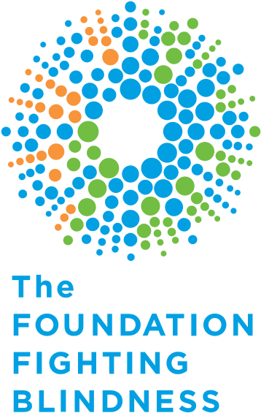
TOGETHER
WE WILL END BLINDNESS.
Thanks to the support of Foundation Fighting Blindness donors, we are continuing to drive the development of sight-saving treatments for the millions of Canadians living with blinding eye diseases.
ffb.ca/donate
ANN MORRISON
Director of Philanthropy
E amorrison@ffb.ca
T 416.360.4200 ext. 232

890 Yonge St. 12th Floor ffb.ca
Toronto, ON, M4W 3P4

1.800.461.3331

