Eye Disease

Fact Sheet

UVEITIS

Uveitis is an inflammatory disease that damages the eye. Uveitis affects different parts of the eye, including the lens, retina, optic nerve, vitreous and the uvea – which includes the iris, ciliary body and choroid (see diagram). It primarily affects people between the ages of 20 and 50, but can occur at any age. It is a leading cause of vision loss in young adults and causes about 20% of legal blindness.
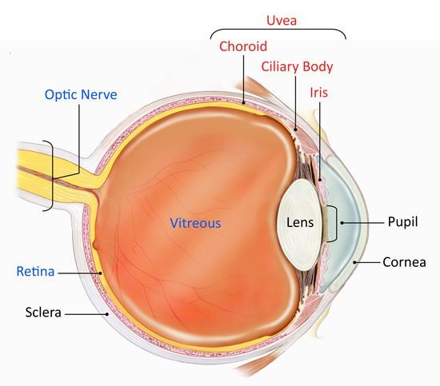
Diagram from the National Eye Institute (https://nei.nih.gov/health/uveitis/uveitis)

Uveitis Symptoms
Uveitis may develop quickly, affecting one or both eyes. If you experience any of these symptoms, please visit your ophthalmologist.
- Light sensitivity
- Flashing lights
- Dark floating spots (floaters)
- Eye pain and/or redness
- Blurred or decreased vision
- Narrowing of the pupils
- Tearing

Detecting and Diagnosing Uveitis
Each year, about 2% of the population is newly diagnosed with uveitis – a disease that takes various forms. It can be infectious or non-infectious. Your ophthalmologist will offer a more specific diagnosis, depending on where the disease is occurring in the eye.
Different tools are used to diagnose uveitis, including: an eye chart to evaluate visual acuity, a funduscopic exam to look at the back of the eye, an ocular pressure test, and other tools to examine the front and back of the eye. In addition, your doctor will conduct a more thorough examination (full patient history) because uveitis is an inflammatory disease that is often associated with another disease.
Anterior uveitis is the most common form, predominantly affecting young and middle-aged people. It causes eye redness and pain, blurred vision, light sensitivity and small pupils. It occurs in the front of the eye and is often associated with other inflammatory and infectious diseases. Eye drops are the main form of treatment.
Intermediate uveitis mostly affects young adults and occurs in the vitreous. Usually, it is not painful, but causes blurred vision and floaters. It is often associated with other diseases.
Posterior uveitis is the least common form of the disease. It occurs in the back of the eye, affecting the retina and the choroid.

Pan-uveitis affects all parts of the eye and can cause blindness if not treated.

Causes and Risk Factors
Uveitis is caused by inflammatory responses in the eye. Inflammation is your body’s response to harmful stimuli, such as toxins, germs or an eye injury.
Inflammatory cells enter the eye around the uvea, where many of the eye’s blood vessels are located.
In about 50% of uveitis cases, the exact cause of the disease is not clear; this is called idiopathic uveitis. Other times, uveitis is linked to a clear cause, such as an eye injury, an infection, a tumour, or an autoimmune attack. Uveitis is often associated with other diseases, such as:
- Arthritis (various syndromes)
- Behcet’s syndrome
- Herpes zoster infection
- Histoplasmosis
- Gastrointestinal diseases
- Multiple sclerosis
- Psoriasis
- Tuberculosis
- Vogt-Koyanagi-Harada syndrome

Treatment
Four different kinds of medication are used to treat uveitis by eliminating inflammation, reducing pain, preventing tissue damage, and restoring vision. These treatments involve different side effects, which you should discuss with your doctor. If left untreated, uveitis can cause lead to glaucoma, cataracts, and permanent vision loss.
- Cycloplegics are given as eye drops to block nerve impulses, reduce pain and light sensitivity, and prevent further complications. Some common drops include: homatropine, atropine, cyclopentolate, and mydriacyl.

- Corticosteroids are used to reduce irritation and swelling and can be taken as a pill, eye drops, intravenously, injections around or into the eye, or released into the eye through a surgical implant. Commonly used corticosteroids include: prednisolone acetate, prednisolone phosphate, rimexolone, and prednisone.

- Immunosuppressive agents are usually taken as a pill to reduce irritation and inflammation. Common medications include: methotrexate, mycophtnolate, azathrioprine, cyclosporine and biologics.

- Non-steroidal anti-inflammatory drugs (NSAIDs) are widely used medications that help to reduce irritation and swelling in uveitis.
Common medications include: diclofenac, ketorolac tromethamine, nepafenac, celecoxib, naproxen, and indomethacin.

There are many treatment options for uveitis. Talk to your doctor to learn what is best for you. Treatment is essential to preserve and even restore your vision.

