Vision Quest Toronto: The Science of Restoring Sight
Tuesday, November 12
PROGRAM

5:00 – 6:30 pm - Registration opens, exhibitor demonstrations and dinner
Frontier Accessibility will be holding technology demonstrations at 5:30 pm and 6 pm at their table

6:30 pm – 6:40 pm: Welcome Remarks
Doug Earle, President & CEO, Fighting Blindness Canada

6:40 - 6:50 pm: FBC eSight Special Presentation

6:50 pm – 7:30 pm: The Future of Ocular Regenerative Medicine: More Than Meets the Eye
Dr. Brian Ballios, Chief Resident in Ophthalmology & Senior Research Associate, Department of Ophthalmology & Vision Sciences, University of Toronto
In this presentation, Dr. Ballios will provide a window into the latest advances in stem cell research applied to ocular regenerative medicine, including inherited retinal degenerations. He will show how our understanding of stem cell biology has created a paradigm shift in our identification of new disease targets, preclinical models of disease, and novel therapeutics that are finding a place in clinical application.

7:30 pm – 8:10 pm: Update on Gene Therapy Trials for Inherited Retinal Diseases
Dr. Michel Michaelides, BSc, MB BS, MRCOphth, MD(Res), FRCOphth, FACS

Recent breakthroughs mean that gene therapy is providing true hope for those living with blinding eye disease. Dr. Michaelides is the Head of Clinical Ophthalmology for MeiraGTx, a clinical-stage gene therapy company who are researching gene therapy for x-linked RP, achromatopsia and LCA. Dr. Michaelides shares his thoughts on the future of this revolutionary field, his experience as a clinical researcher and discusses how vision researchers are moving gene therapy forward.
8:10 pm – 8:15 pm: Closing Remarks

SPEAKER BIOS

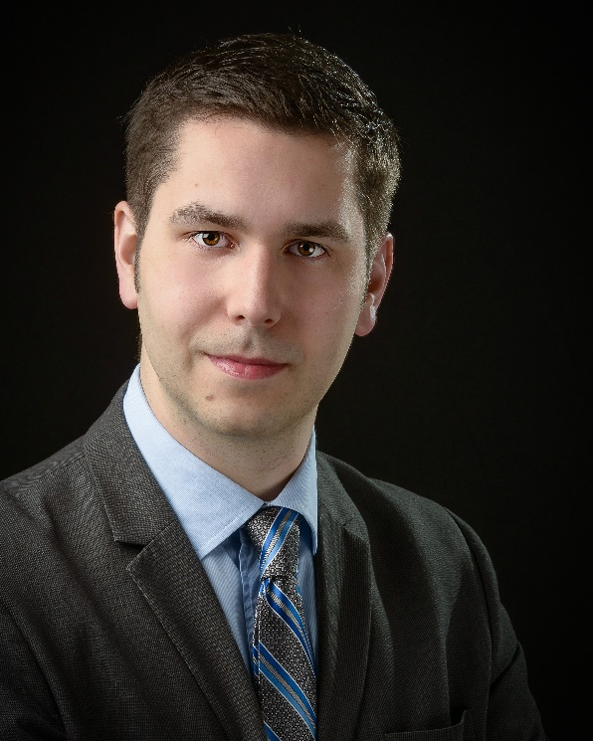
Dr. Brian Ballios is currently the Chief Resident in Ophthalmology at the University of Toronto, as well as a Senior Research Associate in the Department of Ophthalmology and Vision Sciences. He is in inaugural recipient of the Clinician Scientist Emerging Leader Award from Fighting Blindness Canada, which aims to strengthen the community of ophthalmologist-scientists. His work has also been funded by the BrightFocus Foundation and Retina Foundation of Canada. Dr. Ballios completed his PhD through the University of Toronto’s MD/PhD Physician Scientist Training Program, where his work focused on developing new approaches to the transplantation of stem cells and their progeny for the treatment of retinal degeneration. As a physician and engineer, his ongoing research draws on his expertise in regenerative medicine and bioengineering to develop new therapies for inherited retinal degenerations.

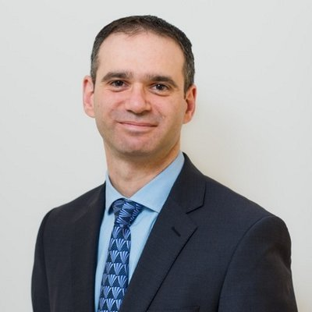
Dr. Michel Michaelides is a Consultant Ophthalmologist at Moorfields Eye Hospital in the departments of Medical Retina, Inherited Eye Disease and Paediatric Ophthalmology; and is a Professor of Ophthalmology at the UCL Institute of Ophthalmology. He is a recipient of a Career Development Award from the Foundation Fighting Blindness (USA) – an award rarely given to non-US applicants; and has gained membership of the highly prestigious Macula Society and Retina Society in the USA.
His clinical and research interests include diabetic eye disease and inherited eye disease in adults and children; with over 300 peer-reviewed publications and 30 co-authored book chapters. He is actively involved in retinal clinical trials investigating novel and established therapies, being a principal investigator in 7 on-going clinical trials.

