WELCOME

Welcome to View Point, Fighting Blindness Canada’s new virtual education series that brings the latest in vision research directly to you at home. Over the next several weeks, join us in exploring cutting edge vision research, new treatments for blinding eye diseases, and more.
View Point will present a combination of live webinars and pre-recorded sessions, covering a range of topics including; gene therapy, pharmaceutical treatments, age-related vision loss, and inherited retinal disease. To keep up to date on upcoming session and view video of past webinars, please visit our virtual events page.
If you would like to receive email updates about new webinars or to share future webinar topic ideas, please email mineson@fightingblindness.ca.

Thank you,
Doug Earle
CEO & President
Fighting Blindness Canada

VIEW POINT PROGRAM
Managing Eye Care in the COVID-19 Era | Thursday, April 16, 2020 at 4 p.m. ET
In this live webinar, Dr. Netan Choudhry will discuss some of the challenges in treating retinal eye disease in the age of COVID-19. He will also give a brief overview of age- related macular degeneration and talk about emerging treatments.
There will be time for Q&A. You will be able to type your questions in a Q&A box or “raise your hand” to ask a question. Full instructions on how to do this will be explained during the webinar. If you are watching this webinar after the live event you may send your questions to mineson@fightingblindness.ca.

ABOUT THE SPEAKER
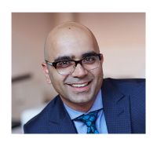
Dr. Netan Choudhry, MD, FRCSC, DABO
Dr. Netan Choudhry is the co-founder and medical director of the Vitreous Retina Macula Specialists of Toronto, a premier academic retina practice. He is Internationally recognized Vitreoretinal Surgeon with affiliations at both the University of Toronto and Harvard Medical School and Ophthalmology Lead at the Cleveland Clinic Canada. He is universally recognized as a thought leader in retinal imaging and the diagnosis and treatment of rare disorders of the retina and vitreous.
Dr. Choudhry was one of the first to pioneer OCT imaging of the peripheral retina and is actively developing novel devices for imaging the retina and vitreous using non-invasive technology. He has published in the world’s most read/indexed journals including: The New England Journal of Medicine, the Lancet, Ophthalmology and the Retina Journal.
Dr. Choudhry’s innovative work in the field of retina has also been published on the covers of numerous journals further earning him the distinction of a pioneer in retinal imaging. His current research focus continues to be in the integration of novel retinal imaging technologies with Artificial Intelligence and imaging biomarkers.
He is an elected member of the Retina Society and Macula Society. He has been a member of the board of directors at the American Society of Retina Specialists, Canadian Retina Society and currently sits on the Board of Directors of Fighting Blindness Canada.

GET INVOLVED
Now, more than ever, we need your support! View Point is free of charge for all participants. If you would like to support this program and the important sight-saving research funded by Fighting Blindness Canada, please make a donation today!
Every year, people across Canada join the fight against blindness by participating in our signature fundraising events: Last Call, Cycle for Sight, Comic Vision and Ride for Sight. Thousands of motorcyclists, comedy fans and cyclists coast-to-coast fundraise for vision research, bringing us closer than ever to treatments and cures for blinding eye diseases. Find out how you can become a participant or ‘virtual rider’ and raise money for sight-saving research by calling 1.800.461.3331 ext. 231 or visiting our event websites:
lastcalltoronto.ca | cycleforsight.ca | comicvision.ca | rideforsight.com

FBC HEALTH INFORMATION LINE
Fighting Blindness Canada is here to support you!
This past year Fighting Blindness Canada launched a Health Information Line so our community could have someone to contact with their vision health related questions. If you have any questions regarding your eye health and how COVID-19 may be affecting it, please reach out to the line by phone 1-888-626-2995 or email healthinfo@fightingblindness.ca.

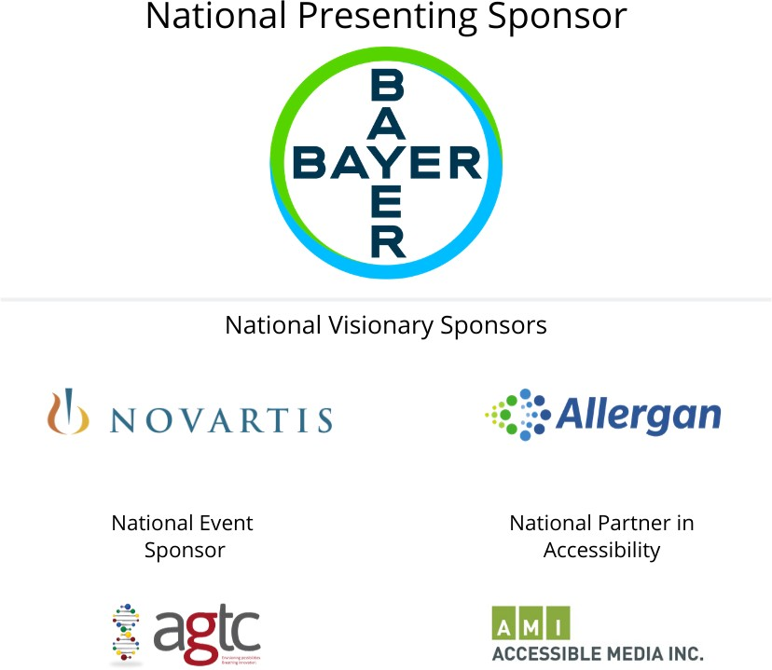
THANK YOU TO OUR SPONSORS

