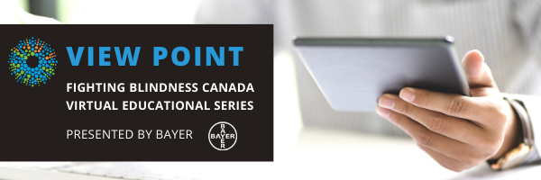

WELCOME

Welcome to View Point, Fighting Blindness Canada’s new virtual education series that brings the latest in vision research directly to you at home. Over the next several weeks, join us in exploring cutting edge vision research, new treatments for blinding eye diseases, and more.
View Point will present a combination of live webinars and pre-recorded sessions, covering a range of topics including; gene therapy, pharmaceutical treatments, age-related vision loss, and inherited retinal disease. To keep up to date on upcoming session and view recordings of past webinars, please visit our virtual events web page.
If you would like to receive email updates about new webinars or to share future webinar topic ideas, please email mineson@fightingblindness.ca.

Thank you,
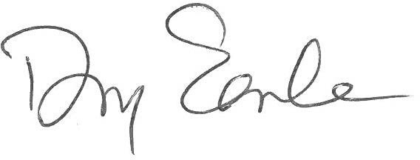
Doug Earle
CEO & President
Fighting Blindness Canada

VIEW POINT PROGRAM
Current Trends in Low Vision Devices | Monday, April 27, 2020 at 4 p.m. ET
In this live webinar, optometrists Dr. Selena Friesen and Dr. Michael Nelson will provide insights on some of the most popular low vision devices available and how they can help maximize your vision.
There will be time for a question and answer period at the end of the webinar. You will be able to type your questions into the Zoom Webinar Q&A box or use the “raise your hand” feature to ask a question using your device microphone. Full instructions on how to do this will be shared during the webinar. Questions after the webinar can also be emailed to mailto:mineson@fightingblindness.ca.

ABOUT THE SPEAKERS
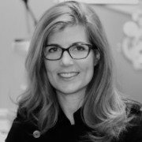
Dr. Selena Friesen grew up in Winnipeg and did her undergraduate science degree at the University of Manitoba. She graduated with honours from the University of Waterloo School of Optometry and received the Johnson & Johnson Award for Excellence in Contact Lens patient care. She also spent time training at eye clinics in Birmingham, Alabama, and Alberta. Dr. Friesen has completed additional certification in Vision Training, Learning Assessments, and Sports Vision. With her husband, Dr. Michael Nelson, they opened Eye Canada (providing low vision devices and services), The Eye Gym (providing vision therapy), and Eyes on Bridgwater. Dr. Friesen was a Board member of the Optometry Examining Board of Canada (OEBC) and currently serves on the boards of the Winnipeg Symphony Orchestra and Mennonite Central Committee.
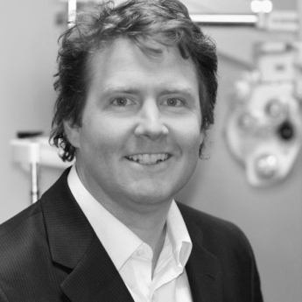
Dr. Michael Nelson grew up on a hog farm in Wetaskiwin, Alberta and studied science at the University of Alberta. He received his Optometry degree from the University of Waterloo School of Optometry in Ontario in 1994 and then completed his family practice and low vision residency at the University of Alabama in Birmingham School of Optometry. He served as the continuing education chair for the Manitoba Association of Optometrists (MAO), and was the president of the MAO from 2000-2003. In 2011 Dr. Nelson co-chaired the Canadian Association of Optometrists Congress in Winnipeg. Dr. Nelson was co-awarded the Manitoba Optometrist of the Year in 2014 for his work on legislation to allow Manitoba Optometrists to write prescriptions for medications to treat eye diseases. Dr. Nelson is currently the President of the Canadian Association of Optometrists.

GET INVOLVED
Now, more than ever, we need your support! View Point is free of charge for all participants. If you would like to support this program and the important sight-saving research funded by Fighting Blindness Canada, please make a donation today!
Every year, people across Canada join the fight against blindness by participating in our signature fundraising events: Last Call, Cycle for Sight, Comic Vision, and Ride for Sight. Thousands of motorcyclists, comedy fans, and cyclists coast-to-coast fundraise for vision research, bringing us closer than ever to treatments and cures for blinding eye diseases. Find out how you can become a participant or ‘virtual rider’ and raise money for sight-saving research by calling 1.800.461.3331 ext. 231 or visiting our event websites:
lastcalltoronto.ca | cycleforsight.ca | comicvision.ca | rideforsight.com

FBC HEALTH INFORMATION LINE
Fighting Blindness Canada is here to support you!
This past year Fighting Blindness Canada launched a Health Information Line so our community could have someone to contact with their vision health related questions. If you have any questions regarding your eye health and how COVID-19 may be affecting it, please reach out to the line by phone 1-888-626-2995 or email healthinfo@fightingblindness.ca.

HELP US ADVOCATE
Fighting Blindness Canada wants to hear from you! By filling out our surveys you’re telling policy makers what it’s like to live with vision loss and why it’s so crucial that new treatments are made available and accessible to all Canadians. We currently have three anonymous and confidential surveys available. You can complete multiple surveys if you have more than one eye condition:
- Living with an inherited retinal disease (IRD)
- Living with age-related macular degeneration (AMD)
- Living with diabetic retinopathy (DR) or diabetic macular edema (DME)
Know someone living with these eye conditions? Share the survey links with them. The more feedback we collect, the greater the impact.

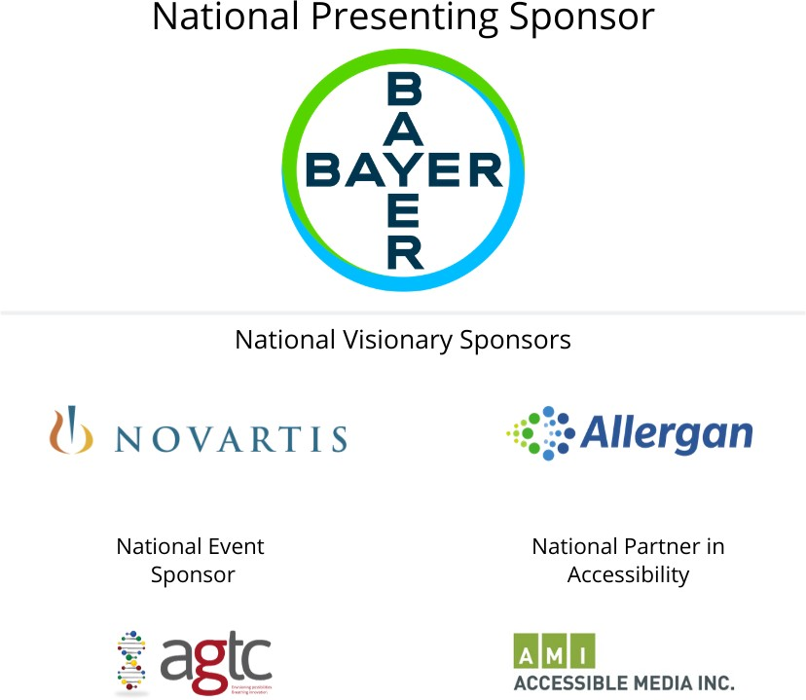
THANK YOU TO OUR SPONSORS

