Screens Off for Sight Social Media Kit

Three Ways to Participate on Social Media

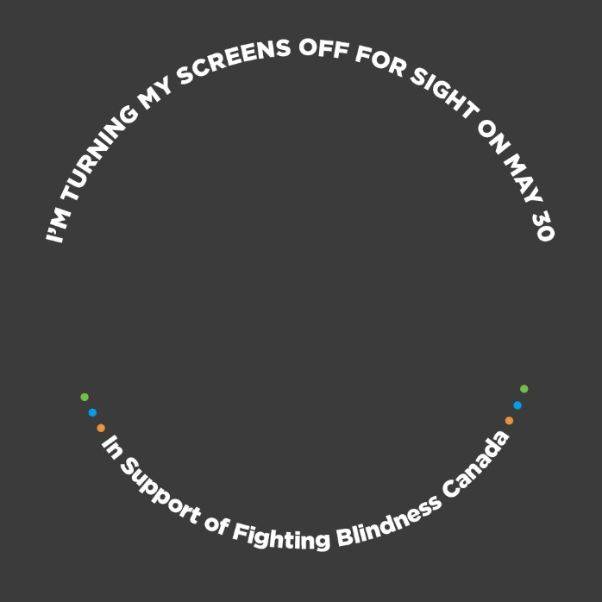
1 – Change your Facebook Profile Photo
Change your Facebook profile photo to our Screens off for Sight frame to provide awareness and encourage donations/participation.
How to do this:
- Log into Facebook. Go to your profile photo. Select edit.
- Select add frame. Search for Screens Off for Sight. Select update/save.
- Optional: Add your Sight Saver fundraiser page link to your Facebook profile biography. Select update bio, copy and paste in link.

2 – Share a Post on your Channels
Share a post across any of your social media channels. Include a link to your Sight Savers fundraising page in your post and don’t forget to use #ScreensOffForSight and tag us at @FightingBlindnessCanada.
Here’s a post you can copy and paste, and use on the day of the challenge (May 30):
For the next 24 hours starting at 6 p.m. I am turning off my screens to support Fighting Blindness Canada’s mission to fund sight-saving research. Over 1.5 million Canadians live with blinding eye disease and are challenged to view their screens each day. Donate to my efforts and join me as I “go dark” to help raise awareness. << ENTER YOUR SIGHT SAVER FUNDRAISING PAGE LINK >>
TIP: Tag a friend(s) to join you in the Screens off for Sight challenge!
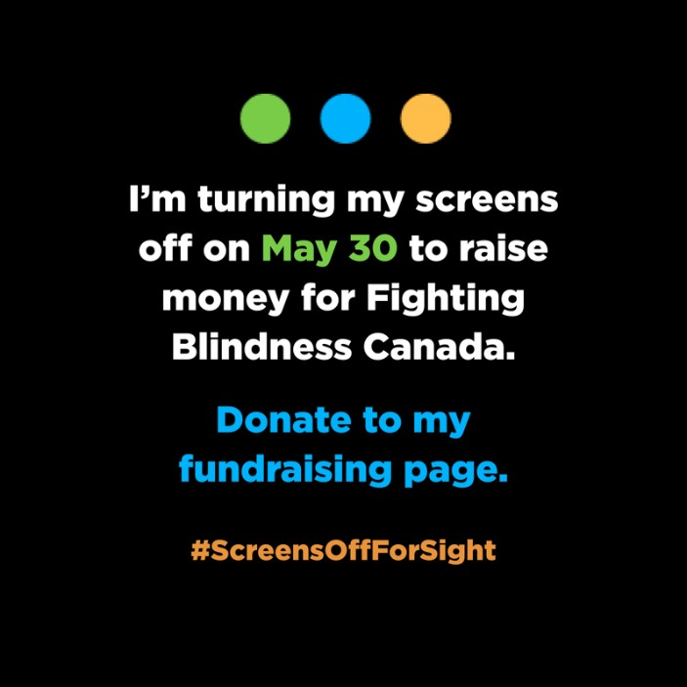
Here’s a photo you can add to your post too!
To save and post the photo on your social media channel from a desktop computer…
- Right-click and select “save as picture”.
- Select the folder you would like to save the picture.
- Once saved, open you social media channel.
- Select the create post option.
- In the post box, copy and paste the sample post we provided above.
- Select the add photo option (photo icon on the bottom).
- Find the saved picture in your folder and select.
- It will automatically add this photo to your post.
- Select “Post” on the right when finished.

3 – Share a Facebook or Instagram Story
Instagram and Facebook Stories are a great way to help raise awareness and encourage donations/participation.
To help get you started, we’ve created a set of story images that can be downloaded and used on both Facebook and Instagram. Stories on Instagram can only be uploaded using a mobile device.
How to add a story using a mobile device:
- Select a photo you would like to use from our Image template folder and use the download photo function. You can also use a photo of your own if you prefer.
- Open your Facebook or Instagram profile account.
- Select the “add story” on the top left, or select the “+” sign on your profile photo.
- Once selected, swipe up to navigate to your photo gallery. Select the photo you downloaded (or a personal photo). This will automatically enter the photo into your Story board.
- With the text option (top right), add in a #ScreensoffforSight hashtag to the photo.
- Select “add story” (bottom left) to finish.
TIP: Stories are designed to be personalized. Text overlay, stickers, and gifs are encouraged! Tag your friends and challenge them to participate with you! Download all the visuals in this toolkit here.
TEMPLATE 1 (To be used prior to May 30) TEMPLATE 2 (To be used on May 30 before 6 p.m.)
