WELCOME

Welcome to View Point, Fighting Blindness Canada’s new virtual education series that brings the latest in vision research directly to you at home. Over the next several weeks, join us in exploring cutting edge vision research, new treatments for blinding eye diseases, and more.
View Point will present a combination of live webinars and pre-recorded sessions, covering a range of topics including; gene therapy, pharmaceutical treatments, age-related vision loss, and inherited retinal disease. To keep up to date on upcoming session and view recordings of past webinars, please visit our virtual events web page.
If you would like to receive email updates about new webinars or to share future webinar topic ideas, please email mineson@fightingblindness.ca.

Thank you,
Doug Earle
CEO & President
Fighting Blindness Canada

VIEW POINT PROGRAM
New Research into Retinopathy of Prematurity | Tuesday, May 19, 2020, 3 p.m. ET
In this live webinar, Dr. Tianwei (Ellen) Zhou will speak about Retinopathy of Prematurity (ROP), a blinding eye disease that affects many premature babies. In this talk, she will discuss what ROP is, its impact on patient lives, current treatments, and what needs to be done in the future. Dr. Tainwei’s upcoming project on ROP is supported by the FBC Clinician-Scientist Emerging Leader (CSEL) Award.
There will be time for a question and answer period at the end of the webinar. You will be able to type your questions into the Zoom Webinar Q&A box or use the “raise your hand” feature to ask a question using your device microphone. Full instructions on how to do this will be shared during the webinar. Questions after the webinar can also be emailed to mineson@fightingblindness.ca

ABOUT THE SPEAKER

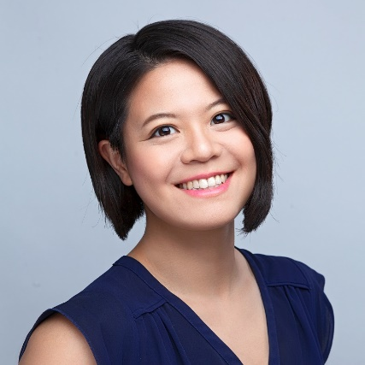
Dr. Tianwei (Ellen) Zhou obtained her M.D. and Ph.D. degrees at McGill University in Montréal, Canada. She is pursuing her Ophthalmology residency at the Université de Montréal. Her research focuses on Retinopathy of Prematurity, a blinding eye disease that affects many premature babies. Her past research and advocacy work were recognized by Canadian Institutes of Health Research MD/PhD grant, Fonds de Suzanne Véronneau-Troutman, as well as the 2017 Canadian Medical Hall of Fame Student Award. Her upcoming project is supported by the FBC Clinician-Scientist Emerging Leader (CSEL) Award

GET INVOLVED
Now, more than ever, we need your support! View Point is free of charge for all participants. If you would like to support this program and the important sight-saving research funded by Fighting Blindness Canada, please make a donation today!
Every year, people across Canada join the fight against blindness by participating in our signature fundraising events: Last Call, Cycle for Sight, Comic Vision, and Ride for Sight. Thousands of motorcyclists, comedy fans, and cyclists coast-to-coast fundraise for vision research, bringing us closer than ever to treatments and cures for blinding eye diseases. Find out how you can become a participant or ‘virtual rider’ and raise money for sight-saving research by calling 1.800.461.3331 ext. 231 or visiting our event websites:
lastcalltoronto.ca | cycleforsight.ca | comicvision.ca | rideforsight.com

FBC HEALTH INFORMATION LINE
Fighting Blindness Canada is here to support you!
This past year Fighting Blindness Canada launched a Health Information Line so our community could have someone to contact with their vision health related questions. If you have any questions regarding your eye health and how COVID-19 may be affecting it, please reach out to the line by phone 1-888-626-2995 or email healthinfo@fightingblindness.ca.

HELP US ADVOCATE
Fighting Blindness Canada wants to hear from you! By filling out our surveys you’re telling policy makers what it’s like to live with vision loss and why it’s so crucial that new treatments are made available and accessible to all Canadians. We currently have three anonymous and confidential surveys available. You can complete multiple surveys if you have more than one eye condition:
- Living with an inherited retinal disease (IRD)
- Living with age-related macular degeneration (AMD)
- Living with diabetic retinopathy (DR) or diabetic macular edema (DME)
Know someone living with these eye conditions? Share the survey links with them. The more feedback we collect, the greater the impact.

THANK YOU TO OUR SPONSORS
