WELCOME

Welcome to View Point, Fighting Blindness Canada’s new virtual education series that brings the latest in vision research directly to you at home. Over the next several weeks, join us in exploring cutting edge vision research, new treatments for blinding eye diseases, and more.
View Point will present a combination of live webinars and pre-recorded sessions, covering a range of topics including; gene therapy, pharmaceutical treatments, age-related vision loss, and inherited retinal disease. To keep up to date on upcoming session and view recordings of past webinars, please visit our virtual events web page.
If you would like to receive email updates about new webinars or to share future webinar topic ideas, please email mineson@fightingblindness.ca.

Thank you,
Doug Earle
CEO & President
Fighting Blindness Canada

VIEW POINT PROGRAM
Emerging Sight-Saving Drug Therapies | Wednesday, May 6, 2020 at 4 p.m. ET
In this engaging discussion, scientists, clinicians, and industry experts will showcase key translational research efforts that are underway in Canada and around the globe to develop new sight-saving drugs. New clinical trial opportunities for Canadians will be introduced. This session was recorded at Vision Quest Vancouver in April 2019.
Dr. Orson Moritz will be joining us after the recording to answer your questions. You will be able to type your questions into the Zoom Webinar Q&A box or use the “raise your hand” feature to ask a question using your device microphone. Full instructions on how to do this will be shared during the webinar. Questions can also be emailed to mineson@fightingblindness.ca before, after or during the webinar.

ABOUT THE SPEAKERS

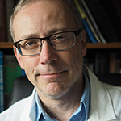
Dr. Orson Moritz, Associate Professor, Department of Ophthalmology and Visual Sciences, University of British Columbia
Dr. Moritz attended University of British Columbia for both undergraduate and graduate school, where he first developed an interest in photoreceptors. The experiments done in his lab are helping us understand the underlying defects that lead to RP, and suggest that therapeutic interventions may be possible.

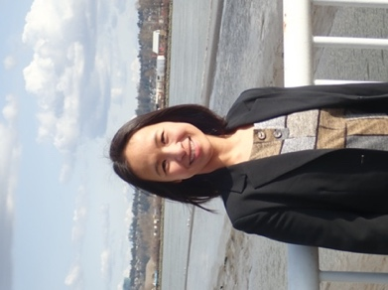
Dr. Ruanne Vent-Schmidt, PhD, University of British Columbia
Dr. Vent-Schmidt's research expertise is on drug therapy for inherited retinal diseases - specifically on the progressive genetic eye condition called retinitis pigmentosa (RP). As a lived experience person affected by RP, Dr. Vent-Schmidt is a leader in the blind/low vision community. She is an advocate for research, science communication, and social equity. In June 2019, Dr. Vent-Schmidt defended her PhD at the University of British Columbia in Cell & Developmental Biology. Since 2015, she has been a public speaker for outreach events for vision research.
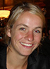
Dr. Hester van Diepen, Project Lead QR-421a (Usher syndrome program), ProQR
Dr. van Diepen currently leads the Usher syndrome development program at ProQR Therapeutics. ProQR Therapeutics is a young biotech company based in Leiden in the Netherlands focusing on the development of RNA therapies for rare genetic diseases. Hester joined ProQR in 2015 after obtaining her PhD in Ophthalmology and Neurophysiology at the Leiden University Medical Center. Since joining ProQR she entirely focuses on the Usher syndrome program to develop an RNA therapy as a treatment for RP caused by mutations in the USH2A gene.
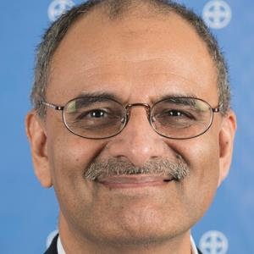
Dr. Shurjeel Choudhri, Senior Vice President and Head, Medical & Scientific Affairs, Bayer
Dr. Choudhri is the Head of Medical and Scientific Affairs (M&SA) for Bayer Inc. He joined Bayer Corporation in 1999 and has had significant experience with the Bayer US and Global medical organizations. Before assuming his current role as Head of M&SA in Canada, Dr. Choudhri was a Global Clinical Leader, Anti-Infectives with Bayer Global Clinical Development. Prior to joining Bayer, Dr. Choudhri was an assistant professor in the Departments of Medical Microbiology and Internal Medicine at the University of Manitoba in Winnipeg. He was also the director of the AIDS program at the St. Boniface General Hospital in Winnipeg; and the Manitoba satellite director for the Canadian HIV Clinical Trials Network.

GET INVOLVED
Now, more than ever, we need your support! View Point is free of charge for all participants. If you would like to support this program and the important sight-saving research funded by Fighting Blindness Canada, please make a donation today!
Every year, people across Canada join the fight against blindness by participating in our signature fundraising events: Last Call, Cycle for Sight, Comic Vision, and Ride for Sight. Thousands of motorcyclists, comedy fans, and cyclists coast-to-coast fundraise for vision research, bringing us closer than ever to treatments and cures for blinding eye diseases. Find out how you can become a participant or ‘virtual rider’ and raise money for sight-saving research by calling 1.800.461.3331 ext. 231 or visiting our event websites:
lastcalltoronto.ca | cycleforsight.ca | comicvision.ca | rideforsight.com

FBC HEALTH INFORMATION LINE
Fighting Blindness Canada is here to support you!
This past year Fighting Blindness Canada launched a Health Information Line so our community could have someone to contact with their vision health related questions. If you have any questions regarding your eye health and how COVID-19 may be affecting it, please reach out to the line by phone 1-888-626-2995 or email healthinfo@fightingblindness.ca.
THANK YOU TO OUR SPONSORS
