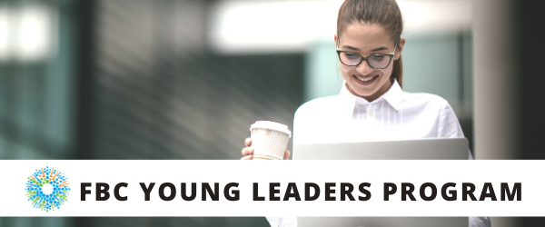

WELCOME
Welcome to Fighting Blindness Canada’s Young Leaders Program. Thank you for joining us as we explore new ways of connecting in our changing world. We hope you will join us for a series of webinars that will explore various topics relevant to young people living with vision loss in Canada.
This year our program is focused on networking and social supports. Networking has become a buzz word in recent years for those seeking employment. Growing your professional and personal networks is essential to growing rewarding careers. Some of the many benefits include; opportunities to learn from others, boosting self-confidence and resilience, and connecting to new people and resources.
If you have any questions or need assistance registering for a webinar, please contact Morgan at mineson@fightingblindness.ca, or 1-800-461-3331 ext. 258.
The FBC Young Leaders Program is proudly sponsored by RBC Future Launch.

Ramya Amuthan
2020 Co-chair, Toronto
Amanda Cape
2020 Co-chair, Montreal
Sarah Patel
2020 Co-chair, Toronto
Haamid Saifee
2020 Co-chair, Edmonton
Morgan Ineson
Manager, Education and Research at Fighting Blindness Canada

WEBINAR PROGRAM
Release Anxiety & Boost Resilience: A Conversation with Laura Feltz
Saturday, May 9, 2020 at 2 p.m. ET
After two decades of working in corporate Human Resources, Laura Feltz found herself career rich and time poor, with a mask of ‘fine” firmly in place. The wakeup call came in the form of a long white cane and a decision to focus on creating heart-centred impact.
Being partially sighted enables Laura to really see the light that you try to dim, diminish, and deflect without seeing their face. A keen listener who tunes into what is getting in the way of playing full out, Laura is a Master NLP Results Coach and Hypnotherapist who is passionate about coaching those ready for a life that’s more than ‘fine’ – helping them step into their power, speak with clarity, and build confidence.

A NOTE FROM LAURA

Life is a bit surreal right now. It can also be a little scary wondering what’s next, right?

What if I told you that you are incredibly resilient? Even if you feel uncertain. Even if you have freaked out a little.

This guided visualization session, designed to release anxiety and boost resilience, will tap into your inner strength. Yes, the inner strength that is at your core.

In this session you will learn:
- The power of the Unconscious Mind
- How our minds are like a smartphone
- What is hypnosis (spoiler alert: it is not what you have seen in movies)

To get maximum benefit from this session, ensure your laptop or device is on a secure surface (e.g. table top), and free of any distractions. Be in comfortable clothes and seated in a comfortable chair where you can fully relax.

ABOUT LAURA FELTZ
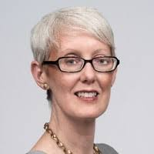
After more than two decades of working in corporate Human Resources where Laura thrived in positions navigating complex, matrixed and global environments, she found herself depleted from going ‘all in’.
When her sight started to significantly declined Laura choose to focus on gratitude, dramatically impacting her experience of sight loss and inspiring others to go beyond what they thought was possible. Her journey has led her to learn how to leverage the power of our unconscious mind and she is coaching to create dramatically different results in people’s lives.
Laura is a Certified Master Results Coach, a Board Designated Institute, Trainer and Master Practitioner of Neuro-Linguistic Programming (NLP), a Board Designated Master Practitioner of Time Line TherapyTM (TLT), and a Board Designated Institute Trainer and Master of Hypnotherapy.
As a volunteer Ambassador for both Fighting Blindness Canada and Canadian National Institute for the Blind, Laura is committed to advocating and raising awareness on navigating in a blurry world. She strives to inspire others by choosing to embrace each day with gratitude, grace, and grit. For more about Laura, visit laurafeltz.com.

FBC HEALTH INFORMATION LINE
Fighting Blindness Canada is here to support you!
This past year Fighting Blindness Canada launched a Health Information Line so our community could have someone to contact with their vision health related questions. If you have any questions regarding your eye health and how COVID-19 may be affecting it, please reach out to the line by phone 1-888-626-2995 or email healthinfo@fightingblindness.ca.
THANK YOU TO OUR SPONSOR
The FBC Young Leaders Program is proudly sponsored by RBC Future Launch.

