WELCOME

Welcome to View Point, Fighting Blindness Canada’s new virtual education series that brings the latest in vision research directly to you at home. Over the next several weeks, join us in exploring cutting edge vision research, new treatments for blinding eye diseases, and more.
View Point will present a combination of live webinars and pre-recorded sessions, covering a range of topics including; gene therapy, pharmaceutical treatments, age-related vision loss, and inherited retinal disease. To keep up to date on upcoming session and view recordings of past webinars, please visit our virtual events web page.
If you would like to receive email updates about new webinars or to share future webinar topic ideas, please email mineson@fightingblindness.ca.

Thank you,
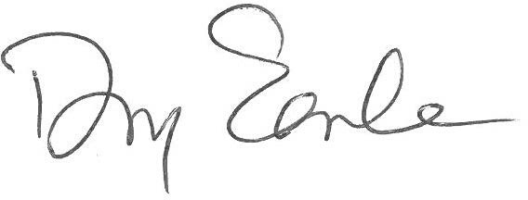
Doug Earle
CEO & President
Fighting Blindness Canada

VIEW POINT PROGRAM
Social Distancing in the Dark | Tuesday, June 16, 2020, 7 p.m. ET
Living under the new restrictions brought upon by the COVID-19 pandemic have forced us all to adapt. Not only have we had to give up activities that we may have taken for granted in the past, but we have also had to learn to be creative in finding ways to enjoy certain necessary activities of daily life. This adaptation is challenging for everyone, but especially challenging for people living with vision loss. In this live webinar, Paralympic swimmer Donovan Tildesley and ophthalmologist Dr. Briar Sexton will speak about some of the key challenges and provide some creative workarounds for people to consider.

There will be a question and answer period at the end of the webinar. Questions can also be emailed to mineson@fightingblindness.ca before, during or after the webinar.

ABOUT THE SPEAKERS
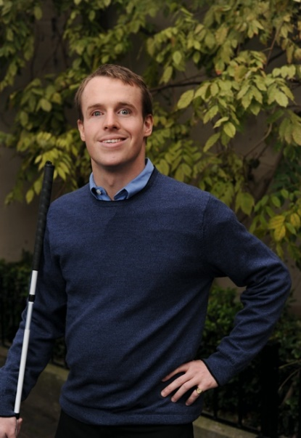
Donovan Tildesley is a 35-year-old Vancouver native and holds a BA degree in English Literature from the University of British Columbia. He is a full-time insurance broker and an accomplished swimmer who has traveled the world extensively.
He has a passion for radio, and was the co-founder of 101.5 Whistler FM. Donovan lives with total blindness since birth due to an eye disease called Leiber’s Congenital Amaurosis.
Despite his blindness, Donovan’s parents were determined to expose him to all types of activities. By age nine, he joined his first swim team, and by age 16 he joined Team Canada, where he competed in the Sydney 2000 Paralympics, winning a bronze medal in the 200 m individual medley (IM).
Coached by his father, Dr. Hugh Tildesley, Donovan’s career highlights include five gold and one silver medal win at the 2002 IPC World Championships, participating in the 2006 Melbourne Commonwealth Games, multiple gold medals at the 2007 Para PanAmerican Games, two silver and one bronze medals at the 2004 Athens Paralympics, and a bronze medal at the 2008 Beijing Paralympics. He also competed in the London 2012 Paralympic Games. Having retired from competitions in 2014, Donovan now focuses his energy at Vancouver’s Buntain Insurance Agencies as a General Insurance Agent, as well as inspiring audiences of all ages to overcome their own life challenges.
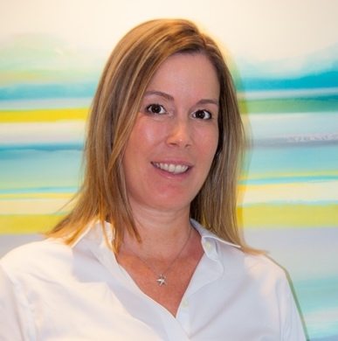
Dr. Briar Sexton is a Clinical Assistant Professor, in the Department of Ophthalmology at the University of British Columbia. Dr. Sexton has a general and neuro-ophthalmology practice in Vancouver, BC. Staying on top of new treatments and maintaining state of the art equipment is important to Dr. Sexton and she is active both in attending and teaching at Continuing Education events.

GET INVOLVED
Now, more than ever, we need your support! View Point is free of charge for all participants. If you would like to support this program and the important sight-saving research funded by Fighting Blindness Canada, please make a donation today!

CYCLE FOR SIGHT
Hundres of cyclists join us each year for our Canada-wide annual Cycle for Sight fundraising event. This year, Cycle for Sight has gone virtual on June 20, 2020! Participants can join us by cycling indoors, walking, running, doing yoga, and more. Registration is free and there are no fundraising minumums. Learn more at cycleforsight.ca.

FBC HEALTH INFORMATION LINE
This past year Fighting Blindness Canada launched a Health Information Line so our community could have someone to contact with their vision health questions. If you have questions regarding COVID-19 and your eye health, please call 1-888-626-2995 or email healthinfo@fightingblindness.ca.

HELP US ADVOCATE
We want to hear from you! By filling out our surveys you’re telling policy makers what it’s like to live with vision loss and why it’s so crucial that new treatments are made available and accessible to all Canadians. The following surveys are currently available:
- Economic impact of inherited retinal distrophies (IRD Counts)
- Living with an inherited retinal disease (IRD)
- Living with age-related macular degeneration (AMD)
- Living with diabetic retinopathy (DR) or diabetic macular edema (DME)
Know someone living with these eye conditions? Share the survey links with them. The more feedback we collect, the greater the impact.

THANK YOU TO OUR SPONSORS
