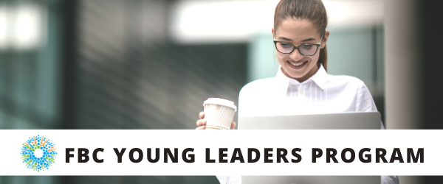

WELCOME
Welcome to Fighting Blindness Canada’s Young Leaders Program. Thank you for joining us as we explore new ways of connecting in our changing world. We hope you will join us for a series of webinars that will explore various topics relevant to young people living with vision loss in Canada.
This year our program is focused on networking and social supports. Networking has become a buzz word in recent years for those seeking employment. Growing your professional and personal networks is essential to growing rewarding careers. Some of the many benefits include; opportunities to learn from others, boosting self-confidence and resilience, and connecting to new people and resources.
If you have any questions or need assistance registering for a webinar, please contact Morgan at mineson@fightingblindness.ca, or 1-800-461-3331 ext. 258.
The FBC Young Leaders Program is proudly sponsored by RBC Future Launch.

Ramya Amuthan
2020 Co-chair, Toronto
Amanda Cape
2020 Co-chair, Montreal
Sarah Patel
2020 Co-chair, Toronto
Haamid Saifee
2020 Co-chair, Edmonton
Morgan Ineson
Manager, Education and Research at Fighting Blindness Canada

WEBINAR PROGRAM
A Conversation on Diversity and Community
Thursday, June 25, 2020 at 7 p.m. ET
Our identities are multifaceted and complex. Multiple intersections between race, ethnicity, disability, gender and orientation affect the way we interact with the world around us, whether it be in the workplace, going to school or seeking a job. Join FBC Young Leaders for a panel discussion about diversity and community as we try to unpack questions surrounding intersectionality, inequality and resistance, and how to be better disability advocates.

ABOUT THE SPEAKERS

Danielle S. McLaughlin happily retired in 2016 after nearly 30 years as Director of Education of the Canadian Civil Liberties Association and Education Trust. In this position she designed and delivered civil liberties and critical thinking programmes for learners in grade school, high school, and faculties of education.
Since retiring, Danielle has published two children’s books: That’s Not Fair! Getting to Know Your Rights and Freedoms (Kids Can Press) in 2016, and Freedom of Expression: Deal with It, (James Lorimer and Company) in 2019. She wrote a monthly blog for Huffington Post for a number of years, and now writes a quarterly blog for Ryerson University’s Centre for Freedom of Expression. Danielle is a member of the board of directors and a volunteer for PAL-Reading Services and has a weekly Know Your Rights segment on AMI’s Kelly and Company, a program which she also co-hosts from time to time. As a TAB (temporarily able-bodied) person, Danielle considers herself to be an activist working for the rights of people living with disabilities.
Sarah Patel has been involved with FBC for the past 4 years. She's studied women and children counselling and has worked in the early childhood sector. As a co-chair this year for the young leaders program she will share her successes and hardships with peers who may have experienced similar challenges.
Bernard Akuoko is a Black male who whose parents were both born in Ghana West Africa. He was diagnosed with Retinitis Pigmentosa at the tender age of 2. Bernard has acquired a Social Service Worker diploma from Sheridan College and later on completed a Social Work degree from Laurentian University. Bernard will be starting his Masters in Social Work this fall. He hopes to cater his studies exploring culture and disability. Currently Bernard works at a school for the blind and visually impaired, which he enjoys the opportunity in propelling youths with vision loss to meet their full potential. Bernard also volunteers within the community as part of the Coalition for Racialized Workers, Diversity Champions, Black Voices group, and as a CNIB and FBC ambassador. Throughout all this Bernard hopes to be a role model to young black kids and youths with vision loss.
George Quarcoo is a multi-talented young man who is a DJ, music producer, a dancer and an athlete. He currently works for Balance for Blind Adults as an Assistive Technology Instructor/Community Engagement Specialist.
Sharie Clarke is 33 years old, lives in Montreal, graduated from Concordia University with a bachelors in human relations, and is a first generation Canadian.

FBC HEALTH INFORMATION LINE
Fighting Blindness Canada is here to support you!
This past year Fighting Blindness Canada launched a Health Information Line so our community could have someone to contact with their vision health related questions. If you have any questions regarding your eye health and how COVID-19 may be affecting it, please reach out to the line by phone 1-888-626-2995 or email healthinfo@fightingblindness.ca.
THANK YOU TO OUR SPONSOR
The FBC Young Leaders Program is proudly sponsored by RBC Future Launch.

