WELCOME

Welcome to View Point, Fighting Blindness Canada’s virtual education series that brings the latest in vision research directly to you at home. This fall, View Point presents a range of topics including age-related macular degneration, glaucoma, diabetic eye disease, and inherited retinal disease.
To keep up-to-date on upcoming webinars and view past View Point webinars, visit our virtual events web page.
If you would like to receive email updates about new webinars or to suggest topics for future webinar, please email education@fightingblindness.ca.

PROGRAM
The Importance of Genetic Testing: A Panel Discussion
Thursday, September 10, 2020, 4 p.m. ET
Are you living with an inherited retinal disease (IRD)? Do you have questions about genetic testing and if it’s right for you? This webinar will discuss genetic testing and its importance in the development of new treatments for blinding eye disease. Hear from experts in the field, learn how you can access this service, and the advantages and challenges of genetic testing.
There will be a question and answer period at the end of the webinar. Questions can be emailed in advance to education@fightingblindness.ca or shared during the question period.

ABOUT THE SPEAKERS
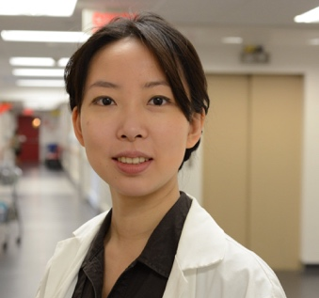
Dr. Cynthia Qian
Dr. Qian is an Assistant Professor in the Department of Ophthalmology and Head of the Electrophysiology Laboratory and the Pediatric Retina Service at the Université de Montréal. Dr. Qian completed her Medical degree at McGill University and become Chief Resident and Valedictorian during her residency in Ophthalmology at the Université de Montréal. She undertook a fellowship in Surgical Retina at the Massachusetts Eye and Ear Infirmary, followed by a fellowship in Retinal Dystrophy at the Kellogg Eye Center, University of Michigan. Dr. Qian is an expert on retinal dystrophy, particularly on the surgical implantation of retinal chips and prostheses. Her areas of focus include adult and pediatric surgical retina and inherited retinal diseases.
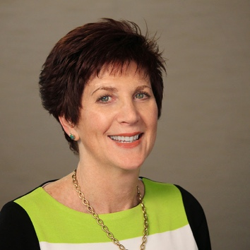
Dr. Jill Dolgin
Jill Dolgin, PharmD is the Head of Patient Advocacy at Applied Genetic Technologies Corporation (AGTC) which is a clinical-stage biotechnology company developing transformational genetic therapies for inherited retinal diseases. Dr. Dolgin leads the patient and professional engagement strategy to drive disease awareness and clinical trial recruitment efforts for the AGTC pipeline. She is responsible for incorporating the voice of the patient throughout drug development and corporate culture. She has over 20 years of global biopharmaceutical experience in Medical Affairs, Corporate Communications, Patient and Professional Advocacy, and Public Policy. Dr. Dolgin earned a Doctorate in Clinical Pharmacy from the University of the Sciences at Philadelphia, and a Bachelor of Science degree in Pharmacy from The Ohio State University.
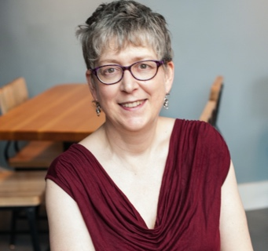
Jill Beis, MSc, CCGC
Jill is a genetic counsellor with Maritime Medical Genetics Services, IWK Health Centre. She graduated from McGill University in 1990 and has worked for MMGS since 1992, with a brief hiatus from August 2001 to June 20003 to work as a research coordinator with Dr. Johane Robitaille in the Eye Clinic at the IWK in hereditary ocular disorders. Jill currently works as a clinical Genetic Counsellor with a special interest in ocular genetics, neurogenetics, and sees patients/families in pediatric and adult genetics clinics.

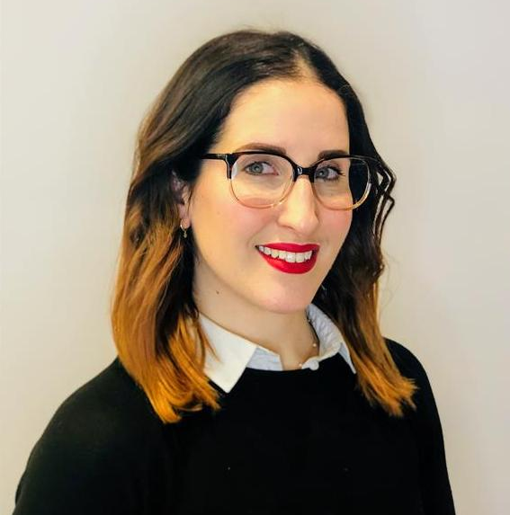
Shari Shaw, MHSc.
Shari Shaw has a Masters in Health Science and is the Health Information Officer at Fighting Blindness Canada, where she provides patient navigation services to the vision loss community and manages the Patient Registry. In this role, she channels her passion for promoting health and wellness through knowledge translation and customer service. Prior to joining Fighting Blindness Canada in 2019, Shari worked in other health fields, including cancer and cardiovascular health.

GET INVOLVED
Now, more than ever, we need your support! View Point is free of charge for all participants. If you would like to support this program and the important sight-saving research funded by Fighting Blindness Canada, please make a donation today!

FBC HEALTH INFORMATION LINE
Our Health Information Lines provides the vision loss community with someone to ask their vision health questions. If you have questions about your eye health, please call 1-888-626-2995 or email healthinfo@fightingblindness.ca

NEW THIS YEAR
Our signature Comic Vision and Last Call fundraising events have joined to bring you a virtual comedy experience! Join us Saturday, October 17th for Comedy from the Couch, brining you laughter and fun in support of sight-saving research. Tickets available at comicvision.ca

THANK YOU TO OUR SPONSORS
