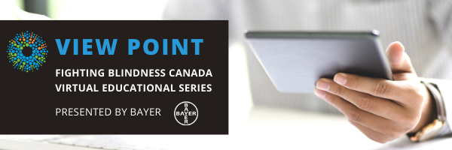

WELCOME

Welcome to View Point, Fighting Blindness Canada’s virtual education series that brings the latest in vision research directly to you at home. This fall, View Point presents a range of topics including age-related macular degneration, glaucoma, diabetic eye disease, and inherited retinal disease.
To keep up-to-date on upcoming webinars and view past View Point webinars, visit our virtual events web page.
If you would like to receive email updates about new webinars or to suggest topics for future webinar, please email education@fightingblindness.ca.

PROGRAM
All Your Questions About AMD Answered
Monday, September 21, 2020, 10 a.m. ET
Are you or someone you know living with age-related macular degeneration (AMD)? Did you know AMD is the leading cause of vision loss in people over the age of 50, affecting approximately 1.4 million Canadians?
In this View Point webinar, retina specialist Dr. Deepa Yoganathan will devote the entire webinar to answering your questions about living with AMD, including how it might affect you, treatment options, and new research.
You will have the opportunity to ask your questions in the session, or you can send them in advance to education@fightingblindness.ca

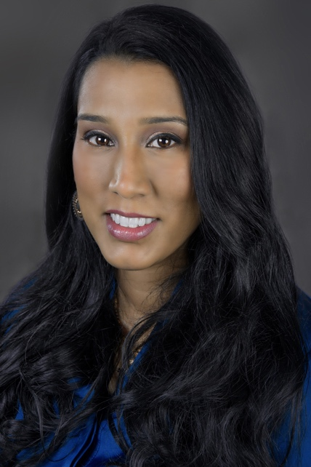
ABOUT THE SPEAKER
Pradeepa Yoganathan is an Assistant Professor in the Department of Ophthalmology and Vision Sciences at the University of Toronto. She is the Co-President of the Toronto Ophthalmological Society.

Dr. Yoganathan also completed the Royal College of Physicians and Surgeons’ Educators Faculty Development Program and was awarded Teacher of the Year by her residents in her first year of practice.

Since 2010, Dr. Yoganathan has been practicing cross-border concurrently in Canada and the United States. Her appointments have included Director of the Retina Department at the University at Buffalo and Assistant Professor at Drexel University and Temple University. She is the recipient of the American Society of Retina Specialists Honour Award and was invited into the International Retinal Imaging Society (IntRIS). Dr. Yoganathan has initiated her own multi-center clinical trial protocols, with research interests in retinal trauma, diabetic retinopathy and macular edema, genetics in macular degeneration, and patient-related outcomes.

Dr. Yoganathan also serves on Fighting Blindness Canada’s Board of Directors and is working closely with us to develop educational materials for the vision loss community

GET INVOLVED
Now, more than ever, we need your support! View Point is free of charge for all participants. If you would like to support this program and the important sight-saving research funded by Fighting Blindness Canada, please make a donation today!

FBC HEALTH INFORMATION LINE
Our Health Information Lines provides the vision loss community with someone to ask their vision health questions. If you have questions about your eye health, please call 1-888-626-2995 or email healthinfo@fightingblindness.ca

NEW THIS YEAR
Our signature Comic Vision and Last Call fundraising events have joined to bring you a virtual comedy experience! Join us Saturday, October 17th for Comedy from the Couch, brining you laughter and fun in support of sight-saving research. Tickets available at comicvision.ca

THANK YOU TO OUR SPONSORS
