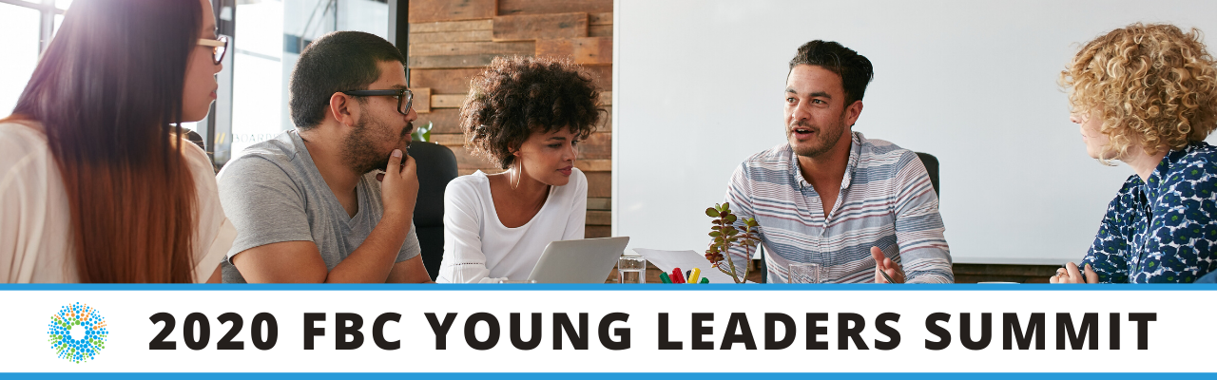

Fighting Blindness Canada’s first VIRTUAL Young Leaders Summit!

Date: October 16-18, 2020
Registration is required, reserve your virtual seat!

New for 2020

Grant opportunity worth $500!

We know how difficult it can be to find work, especially during these challenging times. To support young leaders like you, this year we are offering a Young Leaders Career Advancement Grant worth $500!

How to apply? Record a 30-60 second video describing how you would use $500 to further your career goals, and email your entry to education@fightingblindness.ca. You must be 15-30 years of age to be eligible.

Three finalists will be selected, with one final recipient receiving the grant. The finalists will be voted on during the Young Leaders Summit.

Comedy from the Couch Prize Pack

Comedy from the Couch is a new virtual comedy night experience taking place Saturday, October 17 at 8 p.m. EST in support of sight-saving research.

Registering for the Young Leaders Summit before September 25th automatically enters you in a draw to win 1 of 5 Comedy from the Couch prize packs, including a ticket to the virtual show valued at $150, and a snack basket mailed right to your door!

A special ticket price of $50 will be offered to all Young Leaders Summit participants - a savings of $100! For show details, visit comicvision.ca. To purchase your Young Leaders special price ticket, email Comicvision@fightingblindness.ca

Young Leaders Virtual Summit Program

DAY 1: Friday, October 16, 2020, 6 p.m. – 8 p.m. ET

6 – 7 p.m.: Welcome & Icebreakers with 2020 Young Leader Program Co-Chairs.

7 – 8 p.m.: Opening Doors: Networking and Social Supports
Every year, the Young Leaders Program Co-Chairs select a theme to help guide the program. This year’s theme will focus on the importance of networking and social supports. Join the Co-Chairs for a panel discussion, as they share on their education and employment experience in relation to this theme.

DAY 2: Saturday, October 17, 2020, 2 p.m. – 5 p.m. ET

2-3 p.m.: Keynote Address
Sumaira Latif, Senior Director & Accessibility Leader, Proctor & Gamble
Sam Latif is P&G’s first Company Accessibility Leader and is leading P&G’s thought leadership and commitment to making P&G and its products accessible. Born in the UK, first-generation Scottish-Pakistani, Sumaira lives with blindness and her passion for her work at P&G has been inspired by personal access challenges she has experienced as both a consumer and an employee.

3-4 p.m.: Career Panel
In this panel discussion, a diverse group of individuals living with vision loss will discuss successes and challenges they have experienced on their personal employment journeys.

4-5 p.m.: Interactive Cooking Workshop with Mary Mammoliti.
Mary is a Toronto based influencer and the cook behind Kitchen Confession. She works as a freelance recipe curator, radio and television personality, food blogger, amateur food photographer; and the host of the Kitchen Confession Podcast. Educating and speaking about vision loss is Mary’s passion, inspiring others to find their light of happiness is what drives her. As Mary says, “The bottom line is this: I’m finding the ability in my disability.” For this special workshop, Mary will be developing a new recipe for our Young Leaders. You will receive the exclusive recipe in advance of the summit.

DAY 3: Sunday, October 18, 2020, 11 a.m. – 2:30 p.m. ET

11 a.m.: Mind, Body and Movement.
This two-part workshop will focus on slowing down and letting your mind and body breathe. For the first half hour, we will be joined by certified yoga instructor Frances Wong, who will guide us through gentle movements to wake the body, and then move into breath work to soothe the nervous system. For the second half hour we will be joined by self-defence instructor Johnny Tai. Johnny Tai is a blind and deaf martial arts instructor and counselor who will discuss how this physical activity can empower others who are blind to feel a strong sense of independence and freedom.

12-1 p.m.: RBC Workshop: Meet Ahmad Abukar
Ahmed is a visually impaired accountant with a Certified Public Accountant (CPA) designation who works as a financial analyst at RBC. Moving to Canada from Somalia at a young age, Ahmed did not speak English, had not been to school, and did not know about available adaptive technology. Supported by his family to learn English, Ahmed took this challenge head on and is now fully bilingual. Through hard work and determination Ahmed started his career at RBC through an internship. In this workshop, Ahmad will share his story in the hopes that it might be helpful to anyone facing challenges in their career journey.

1-2:30 p.m.: Roundtable Discussions.
In our final session, we will break into small groups to discuss important topics, including the importance of social supports, professional networking, supporting mental health, and building confidence. Led by the Young Leaders Program co-chairs.

We look forward to connecting with you! Please contact us if you have any questions or need assistance registering at education@fightingblindness.ca

