WELCOME
Welcome to Fighting Blindness Canada’s Young Leaders Program. Thank you for joining us as we explore new ways of connecting in our changing world.
This year, our program bring you topics on networking and social supports. Networking has become a buzz word in recent years for those seeking employment. Growing your professional and personal networks is essential to growing rewarding careers. Some of the many benefits include; opportunities to learn from others, boosting self-confidence and resilience, and connecting to new people and resources.
If you have any questions or need assistance registering for a webinar, please contact Manager of Education and Research, Morgan Ineson at education@fightingblindness.ca or 1-800-461-3331 ext. 258.

PROGRAM CO-CHAIRS
Ramya Amuthan, 2020 Co-chair, Toronto
Amanda Cape, 2020 Co-chair, Montreal
Sarah Patel, 2020 Co-chair, Toronto
Haamid Saifee, 2020 Co-chair, Edmonton

FBC’s Young Leaders Program is proudly sponsored by RBC Future Launch.

WEBINAR PROGRAM
Accessibility & Accommodations at School and Work
Thursday, September 17, 2020, 7 p.m. ET
Whether you’re starting a new job or entering post-secondary education, figuring out what accommodations are available can be complicated and confusing. What are your rights and responsibilities? What should your school or employer be providing to you? In this panel discussion, we will talk to Human Resource and ccessibility professionals and FBC Young Leaders to learn what to expect and how you can self-advocate in order to participate fully in school or the workplace.
A Q&A period will be included. Please email questions in advance to education@fightingblindness.ca

ABOUT THE SPEAKERS
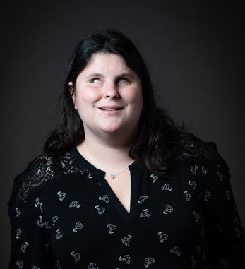
Amanda Cape began her involvement with FBC In 2019 as a Young Leader who attended the Toronto summit. She is 28 years old, has a bachelor’s degree in social work and has just started her masters degree in social work at Ryerson University. She enjoys meeting other Young Leaders who have a visual impairment and learning about their successes, career aspirations, and the hobbies they enjoy.

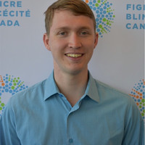
Jack McCormick graduated with high distinction from the Bachelor of Business Administration Program at the Lazardis School of Business and Economics at Wilfred Laurier University in 2018. Currently, he’s working as a Human Resources professional in the healthcare industry. As someone who is blind, he is passionate about inclusion and accessibility, particularly in the workplace. Some of his most notable advocacy accomplishments include: Co-Founding Eye To Eye, a student organization that aims to eliminate stigma associated with sight loss; Co-Chairing the 2018 FBC Young Leaders Summit; and public speaking engagements across North America. Jack is proud to serve as Vice Chair of the CNIB Foundation (Ontario and Quebec) Board of Directors.

Gwen Page is the Director, Accessible Learning at Wilfred Laurier University. Gwen has been in this role with Accessible Learning since 2006 and held variety of roles in the Waterloo community for 20 years prior. This included community development and planning, case management for those with severe and persistent mental health issues and management of the Centres for Mental Health with the Canadian Mental Health Association. She began working as a frontline staff on the newly funded mobile crisis team in 1997 and led its expansion when it became region-wide in 2000. Gwen interfaced with Waterloo Region Police and Hospital systems to ensure seamless delivery of community based crisis services. She completed her Bachelor's degree in Psychology ('85) and her Master's in Community Psychology ('88) at Laurier. Gwen was the proud recipient of Laurier's Multi-Campus Champion Award in 2013.

Involved with the FBC since March of 2017, Haamid Saifee is a recent engineering graduate from the University of Alberta. He currently works as an Estimator for a construction company in Edmonton. As a co-chair of the FBC Young Leaders Program this year, he is focused on sharing his recent successes and hardships with fellow peers who may be experiencing similar challenges. He is particularly interested in starting a dialogue on how to open new doors via social and professional networking.

FBC HEALTH INFORMATION LINE
This past year Fighting Blindness Canada launched a Health Information Line so our community could have someone to contact with their vision health related questions. If you have any questions regarding your eye health and how COVID-19 may be affecting it, please reach out to the line by phone 1-888-626-2995 or email healthinfo@fightingblindness.ca.

