WELCOME

Welcome to View Point, Fighting Blindness Canada’s virtual education series that brings the latest in vision research directly to you at home. This fall, View Point presents a range of topics including age-related macular degneration, glaucoma, diabetic eye disease, and inherited retinal disease.
To keep up-to-date on upcoming webinars and view past View Point webinars, visit our virtual events web page.
If you would like to receive email updates about new webinars or to suggest topics for future webinar, please email education@fightingblindness.ca.

PROGRAM
How the Gut Influences the Development of Retinal Disease
Monday, October 19, 2020, 3 p.m. ET
Dr. Mike (Przemslaw) Sapieha will discuss his internationally renowned research about the role that bacteria in your intestines may play in determining if you will develop wet age-related macular degeneration (AMD). Wet AMD is the more severe form of age-related macular degeneration, and can cause significant loss of sight.
You will have the opportunity to ask your questions in the session, or you can send them in advance to education@fightingblindness.ca

ABOUT THE SPEAKER

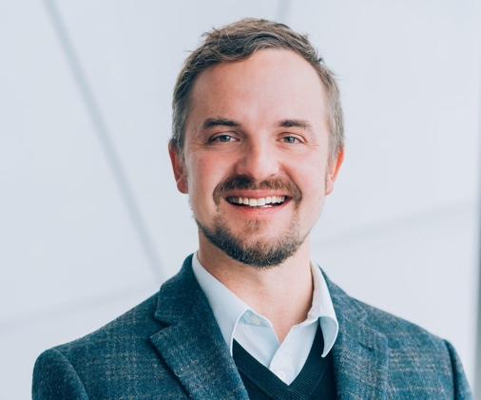
Dr. Mike (Przemyslaw) Sapieha is the director of the Neurovascular Eye Disease Lab at the Maisonneuve-Rosemont Hospital Research Centre and holds the Wolfe Professorship in translational vision research and the Canada Research Chair in retinal cell biology. He is an associate professor in the departments of Ophthalmology and Biochemistry at the University of Montreal and an adjunct professor of Neurology and Neurosurgery at McGill University. In 2018, he was elected to the College of the Royal Society of Canada.

Dr. Sapieha obtained his PhD in neuroscience and cell biology in 2005 at the University of Montreal. He subsequently pursued two postdoctoral fellowships: one in pharmacology at McGill University and the second in ophthalmology at Harvard Medical School.

Dr. Sapieha's research focuses on elucidating the causes of retinal vascular diseases such as diabetic retinopathy and age related macular degeneration. These diseases are the main causes of vision loss in developed countries. To date, he has published over 80 scientific articles in journals such as Cell Metabolism, Nature Medicine, Science Translational Medicine, Science Immunology, Journal of Clinical Investigation, Blood, and more. Dr. Sapieha filled several patents based on his work, and co-founded the biotech company SemaThera Inc of which he is the chief scientific officer.

During his career, Dr. Sapieha has won awards such as the 2019 Cogan Award from the Association for Research and Vision and Ophthalmology, the 2017 Joe Doupe Award from the Canadian Society for Clinical Investigation, the 2017 Canadian Association for Neuroscience Young Investigator Award, and the first Alcon Research Institute Young Investigator Award in 2012.

GET INVOLVED
Now, more than ever, we need your support! View Point is free of charge for all participants. If you would like to support this program and the important sight-saving research funded by Fighting Blindness Canada, please make a donation today!

FBC HEALTH INFORMATION LINE
Our Health Information Lines provides the vision loss community with someone to ask their vision health questions. If you have questions about your eye health, please call 1-888-626-2995 or email healthinfo@fightingblindness.ca

THANK YOU TO OUR SPONSORS
