WELCOME

Welcome to View Point, Fighting Blindness Canada’s virtual education series that brings the latest in vision research directly to you at home. This fall, View Point presents a range of topics including age-related macular degneration, glaucoma, diabetic eye disease, and inherited retinal disease.
To keep up-to-date on upcoming webinars and view past View Point webinars, visit our virtual events web page.
If you would like to receive email updates about new webinars or to suggest topics for future webinar, please email education@fightingblindness.ca.

PROGRAM

Glaucoma: Current & Future Treatment Options
Tuesday, October 6, 2020, 4 p.m. ET
Join Dr. Yvonne Buys to learn more about glaucoma, an eye disease affecting more than 400,000 Canadians. Dr. Buys will provide an overview of glaucoma and discuss current and future treatment options. There will be time for Q&A.
You will have the opportunity to ask your questions in the session, or you can send them in advance to education@fightingblindness.ca

ABOUT THE SPEAKER
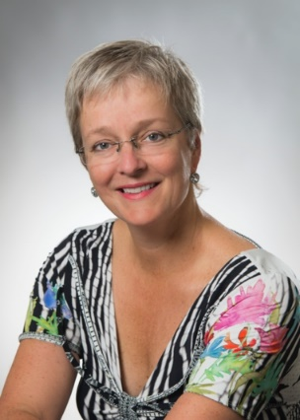
Dr. Yvonne Buys earned her MD degree at the University of Toronto, completing an ophthalmology residency in 1992 followed by a Glaucoma Fellowship in 1993. Today, Dr. Buys is a Professor at the University of Toronto, Department of Ophthalmology and Visual Sciences. Dr. Buys is actively involved in numerous organizations. Positions include past President of the Canadian Ophthamological Society, President of the Toronto Area Glaucoma Society, and President of Canadian Glaucoma Society.
Dr. Buys has been a principal investigator on many research endeavors, and has published over 170 peer-reviewed scientific papers, 16 editorials, and 10 book chapters. She has made over 500 presentations across North America and internationally, and as an educator, has also designed and implemented a comprehensive introductory course for ophthalmology residents at the University of Toronto.

Dr. Buys’ work in Glaucoma
Dr. Buys has been involved in guideline development, including; Clinical Practice Guidelines for the Management of Glaucoma in the Adult Eye (2009), Medical use of Marijuana for Glaucoma (2010), and Medical use of Cannabis for Glaucoma (2018), Collaboration in the care of Glaucoma Patients and Glaucoma Suspects (2011), Screening for Open-Angle Glaucoma Guideline for Family Physicians (2015), and A Practical Guide to the Pregnant and Breastfeeding Glaucoma Patient (2020). From 2014-16 Dr Buys was on the Planning Committee for Glaucoma Subspecialty Day at the American Academy of Ophthalmology (AAO).

GET INVOLVED
Now, more than ever, we need your support! View Point is free of charge for all participants. If you would like to support this program and the important sight-saving research funded by Fighting Blindness Canada, please make a donation today!

FBC HEALTH INFORMATION LINE
Our Health Information Lines provides the vision loss community with someone to ask their vision health questions. If you have questions about your eye health, please call 1-888-626-2995 or email healthinfo@fightingblindness.ca

NEW THIS YEAR
Our signature Comic Vision and Last Call fundraising events have joined to bring you a virtual comedy experience! Join us Saturday, October 17th for Comedy from the Couch, brining you laughter and fun in support of sight-saving research. Tickets available at comicvision.ca

THANK YOU TO OUR SPONSORS
