WELCOME

Welcome to View Point, Fighting Blindness Canada’s virtual education series that brings the latest in vision research directly to you at home. To view upcoming and past View Point webinars, visit our virtual events web page.
If you would like to receive email updates about upcoming webinars or to suggest topics for future webinars, please email education@fightingblindness.ca.

LIVING WELL WITH DIABETIC EYE DISEASE
Tuesday, November 24, 2020, 3 p.m. ET
Managing diabetes can be challenging and complex – even more so if you are living with an eye disease. In this webinar, multi-disciplinary experts will share their perspectives on how you can live well with diabetes. Topics discussed will include practical tips for managing diabetes while living with vision loss, mental health resources and community supports, and hearing from patient partners who have lived experience of diabetes and vision loss.
A Q&A period will be included. Please email your questions in advance to education@fightingblindness.ca or share them in the Zomm chat box during the live webinar.
This View Point webinar is presented in partnership with Diabetes Action Canada.
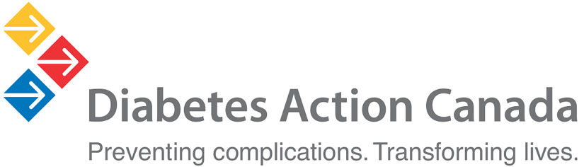

About the Speakers

Diana Sherifali
Diana earned both her BScN (1999) and PhD (2006) from McMaster university. She is an Associate Professor in the School of Nursing at McMaster University and a clinical nurse specialist in the Diabetes Care and Research Program at Hamilton Health Sciences. Having joined McMaster University’s School of Nursing in 2009, Dianaca is also the director of the School of Nursing’s evidence review and synthesis team. Diana was also appointed to the inaugural Heather M. Arthur Population Health Research Institute in 2019.
Diana’s research focuses on optimizing the management of diabetes and quality of life. Her research program engages individuals to effectively self-manage and mitigate the impact of diabetes on their life. Her research examines health coaching and digital solutions to improve health-related outcomes and extend diabetes self-management.

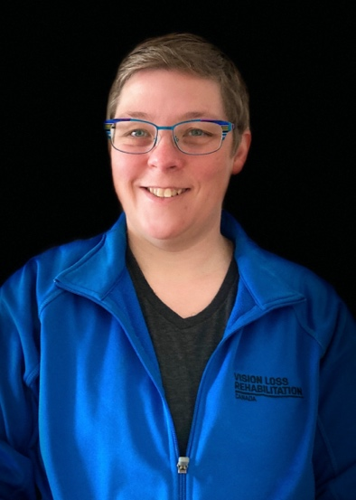
Leanne Baarda
Leanne has worked with Vision Loss Rehabilitation Ontario (VLRO) for the last 11 years as an independent living skills specialist. She holds a bachelor's degree in therapeutic recreation from Concordia University and a post graduate certification in vision rehabilitation from Mohawk College. Leanne is also a certified vision rehabilitation therapist through the Academy for Certification of Vision Rehabilitation & Education Professionals (ACVREP). Prior to working with VLRO, she worked as a recreational therapy assistant at Holland Bloorview Kids Rehab in their inpatient and respite units.
Leanne enjoys running and creating a variety of groups to help client's in their rehabilitation journey. Leanne’s experience spands from youth camps that focus on the expanded core curriculum, to diabetes groups that focus on developing daily living skills, and more. She also enjoys inspiring clients to try new things, like participating in Team CNIB/VLRO mud run obstacle course races, and regularly contributor on AMI’s Kelly and Company show in the Ask an Independent Living Skills (ILS) segment.
In the past, Leanne has also been involved in health professional workshops that educate about VLRO and how to assist individuals living with sight loss in hospital and rehabilitation settings.

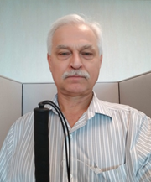
Bert Neutel
Bert, an FBC community member living with vision loss shares about himself.

I have been a diabetic for more than 54 years. I have a good life with the support of my family, wife, and kids. I had a retinopathy flare-up in the 90's and at that time the only treatment was laser cauterization of the retina. 18 laser procedures later, my eyes were stabilized. I mentioned to my doctor that I was getting tired of all these cars running into me. They asked how often this was happening and I answered, at least every few months. So the doctor sent me for some eye tests that went beyond a simple letter chart. I have little peripheral vision or light differentiation, and I have tunnel vision as long as the light is strong. In the best of conditions, I may have 8-9% vision.

Growing up, I played sports, I wasn't very good but I had fun. I continued playing sports until it got too dangerous for me and others playing with me. I was a farmer and then got into computers. First into hardware, then software, and then into general trouble-shooting and project management. I still work in technology and have never let my lack of sight be a lack of vision. There are always problems in life – I just don't let them define me or limit me. People often assume that they do, but I prove them wrong.”

GET INVOLVED
Now, more than ever, we need your support! View Point is free of charge for all participants. If you would like to support this program and the important sight-saving research funded by Fighting Blindness Canada, please make a donation today!

FBC HEALTH INFORMATION LINE
Our Health Information Lines provides the vision loss community with someone to ask their vision health questions. If you have questions about your eye health, please call 1-888-626-2995 or email healthinfo@fightingblindness.ca

THANK YOU TO OUR SPONSORS
