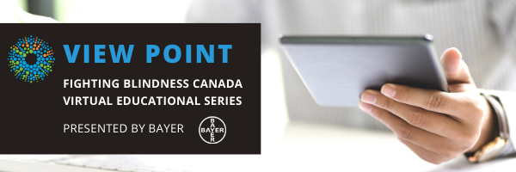

WELCOME

Welcome to View Point, Fighting Blindness Canada’s virtual education series that brings the latest in vision research directly to you at home. This fall, View Point presents a range of topics including age-related macular degneration, glaucoma, diabetic eye disease, and inherited retinal disease.
To keep up-to-date on upcoming webinars and view past View Point webinars, visit our virtual events web page.
If you would like to receive email updates about new webinars or to suggest topics for future webinar, please email education@fightingblindness.ca.

PROGRAM
Diabetes & Vision Loss 101
Tuesday, November 3, 2020, 5 p.m. ET
Did you know that one in three Canadians live with diabetes or pre-diabetes? Diabetes can cause uncontrolled bleeding in the retina, putting people with diabetes at risk of losing their eye sight. In this webinar, Dr. Netan Choudhry will discuss how diabetes affects the eye, what you can do to take care of your eyes, and what treatments are available if your sight is affected by diabetes.
You will have the opportunity to ask your questions in the session, or you can send them in advance to education@fightingblindness.ca

ABOUT THE SPEAKER

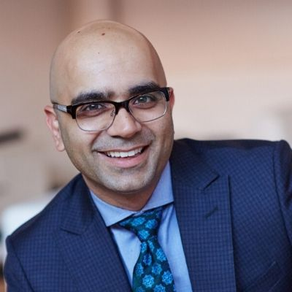
Dr. Netan Choudhry, MD, FRCSC, is the co-founder and medical director of the Vitreous Retina Macula Specialists of Toronto, a premier academic retina practice. He is internationally recognized Vitreoretinal Surgeon with affiliations at both the University of Toronto and Harvard Medical School and Ophthalmology Lead at the Cleveland Clinic Canada. He is universally recognized as a thought leader in retinal imaging and the diagnosis and treatment of rare disorders of the retina and vitreous.

Dr. Choudhry was one of the first to pioneer OCT imaging of the peripheral retina and is actively developing novel devices for imaging the retina and vitreous using non-invasive technology. He has published in the world’s most read/indexed journals including: The New England Journal of Medicine, the Lancet, Ophthalmology and the Retina Journal.

Dr. Choudhry’s innovative work in the field of retina has also been published on the covers of numerous journals further earning him the distinction of a pioneer in retinal imaging. His current research focus continues to be in the integration of novel retinal imaging technologies with Artificial Intelligence and imaging biomarkers.

He is an elected member of the Retina Society and Macula Society. He has been a member of the board of directors at the American Society of Retina Specialists, Canadian Retina Society and currently sits on the Board of Directors of the Foundation Fighting Blindness Canada.

GET INVOLVED
Now, more than ever, we need your support! View Point is free of charge for all participants. If you would like to support this program and the important sight-saving research funded by Fighting Blindness Canada, please make a donation today!

FBC HEALTH INFORMATION LINE
Our Health Information Lines provides the vision loss community with someone to ask their vision health questions. If you have questions about your eye health, please call 1-888-626-2995 or email healthinfo@fightingblindness.ca

THANK YOU TO OUR SPONSORS
