WELCOME

Welcome to View Point, Fighting Blindness Canada’s virtual education series that brings the latest in vision research directly to you at home. In 2020, our View Point Education Webinar Series presented a range of topics including age-related macular degneration, glaucoma, diabetic eye disease, and inherited retinal disease.
To keep up-to-date on upcoming webinars the new year, and access past View Point webinar recording, visit our webinar web page.
If you would like to receive email updates about new webinars or to suggest future webinar topics, please email education@fightingblindness.ca.

PROGRAM
TOPIC: 2020 Vision Research in Review
DATE: Tuesday, December 8, 2020, 3 p.m. ET
Join members of the Fighting Blindness Canada Research & Mission team to recap an exciting year in vision research. Topics will include emerging therapies, research discoveries and new resources.
There will be a question and answer period at the end of the webinar. Questions can be emailed in advance to education@fightingblindness.ca or shared during the question period.

ABOUT THE SPEAKERS

Dr. Larissa Moniz, Director, Research and Mission Programs at Fighting Blindness Canada
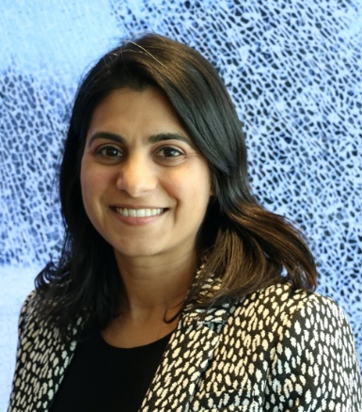
Larissa joined Fighting Blindness Canada in December 2019. She has a PhD in molecular biology from the University of Toronto and continued her research in the UK at University College London. Larissa has worked in research and knowledge translation at a number of health charities in the UK and Canada, most recently at Prostate Cancer Canada. At Fighting Blindness Canada, Larissa’s team works to deliver on the mission of the organization – to fund research towards treatments to preserve and restore vision, ensure that all Canadians have access to appropriate vision care, and to provide support and information to individuals living with vision loss.

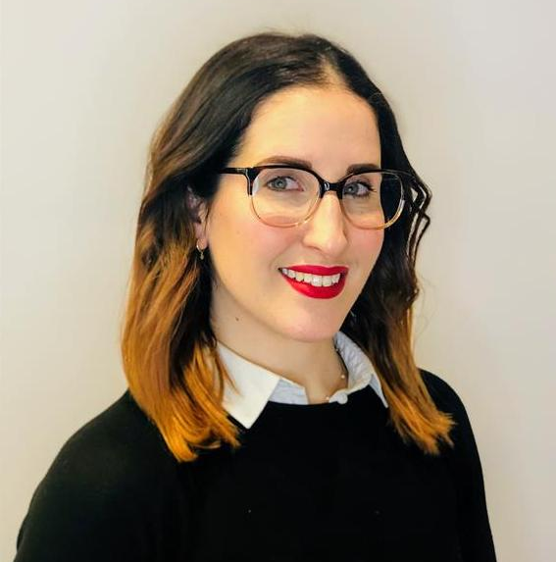
Shari Shaw, MHSc. Health Information Officer at Fighting Blindness Canada
Shari Shaw has a Masters in Health Science and is the Health Information Officer at Fighting Blindness Canada, where she provides patient navigation services to the vision loss community and manages Fighting Blindness Canada’s IRD Patient Registry. In this role, she channels her passion for promoting health and wellness through knowledge translation and customer service. Prior to joining Fighting Blindness Canada in 2019, Shari worked in other health fields, including cancer and cardiovascular health.

GET INVOLVED
Now, more than ever, we need your support! View Point is free of charge for all participants. If you would like to support this program and the important sight-saving research funded by Fighting Blindness Canada, please make a donation today!

FBC HEALTH INFORMATION LINE
Our Health Information Lines provides the vision loss community with someone to ask their vision health questions. If you have questions about your eye health, please call 1-888-626-2995 or email healthinfo@fightingblindness.ca

THANK YOU TO OUR SPONSORS
