WELCOME TO VIEW POINT

Welcome to View Point, Fighting Blindness Canada’s virtual education series that brings the latest in vision research directly to you at home. In 2021, View Point will present topics including age-related macular degneration, glaucoma, gene therapy, caregiving, inherited retinal disease, cateracts, and diabetic eye disease.

To keep up-to-date on upcoming webinars, and access past View Point recordings, please visit our virtual education web page.

If you would like to receive email updates about new View Point webinars or to suggest future webinar topics, please email education@fightingblindness.ca.

WEBINAR PROGRAM
Uncovering the Role of Vitamin D in AMD
Wednesday, February 17, 2021, 10:30 am ET
Exhibitor Showcase
For the first half hour of the webinar, we will be joined by Stephen Ricci from CNIB Smart Life. Stephen will showcase some of the latest and greatest accessible devices and technological aids for people living with vision loss.

Guest Speaker
In this live session we will be joined by FBC-funded researcher and ophthalmologist, Dr. Jacob Rullo who will speak about his research into the connection between vitamin D and age-related macular degeneration (AMD).
There will be a question and answer period at the end of the webinar. Questions can be emailed in advance to education@fightingblindness.ca or shared during the question period.

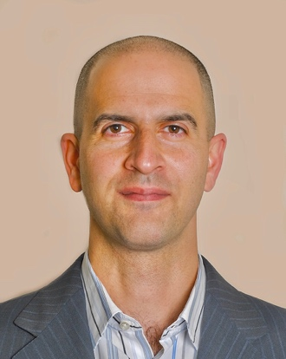
ABOUT THE SPEAKER: DR. JACOB RULLO
I was bitten by the science bug early in life. Inserting lines into the mouse jugular vein and modeling leukocyte recruitment in animal models of disease as a highschool student in 2001, exposed me to the world of research and to the concept of inflammation; a fundamental disease process.
I continued to perform basic science research as an undergraduate student at McMaster University. Subsequently, I entered the MD/PhD program at the University of Toronto in 2006. My research focus was on characterizing what makes white blood cells unique in their ability to stick down while resisting the detaching forces of flowing blood.
During my training, I became very interested in various forms of microscopy and live imaging of leukocytes. My focus and desire to visualize physiology in real time led me to the field of ophthalmology. From 2015 to 2020, I concurrently completed my ophthalmology residency and a post-doctoral fellowship at Queen’s University. I started as a new faculty member at Queen’s University as a clinician-scientist in the Departments of Ophthalmology and Biomedical and Molecular Sciences in July 2020. My research program focuses on characterizing differences in the ocular microenvironment with respect to the discovery of novel biomolecules/biomarkers, understanding intraocular immune mechanisms and the immune biology of the external ocular surface.

EXHIBITOR SHOWCASE
CNIB SmartLife is an interactive retail experience that gives people with disabilities hands-on access to the latest breakthroughs in assistive technologies, as well as tried-and-true favourites. It’s goal is to give customers the skills and confidence they need to make the most out of assistive tools that can help them lead better lives.

Support View Point
Now more than ever, we need your support! View Point is free of charge for all participants. If you would like to support this program and the important sight-saving research funded by Fighting Blindness Canada, please make a donation today!

FBC Health Information Line
Our Health Information Lines provides the vision loss community with someone to ask their vision health questions. If you have questions about your eye health, please call 1-888-626-2995 or email healthinfo@fightingblindness.ca

THANK YOU TO OUR SPONSORS
