WELCOME TO VIEW POINT

Welcome to View Point, Fighting Blindness Canada’s virtual education series that brings the latest in vision research directly to you at home. In 2021, View Point will present topics including age-related macular degneration, glaucoma, gene therapy, caregiving, inherited retinal disease, cateracts, and diabetic eye disease.

To keep up-to-date on upcoming webinars, and access past View Point recordings, please visit our virtual education web page.

If you would like to receive email updates about new View Point webinars or to suggest future webinar topics, please email education@fightingblindness.ca.

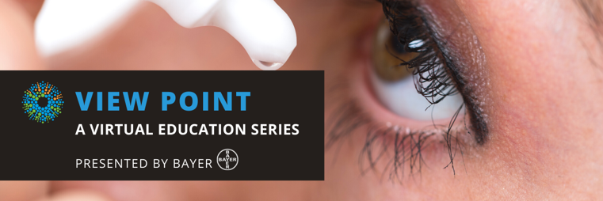
WEBINAR PROGRAM

Glaucoma Doesn’t Discriminate
Wednesday, March 10, 2021, 7 p.m. ET
Community Showcase
We will be joined at the beginning of the webinar by a representative from Allergan-Abbvie who will be sharing details of their forthcoming glaucoma education app.

Guest Speaker
Glaucoma can affect people of all ages and can be a secondary complication for people with other eye diseases. Join Dr. Raageen Kanjee for a discussion all about glaucoma and how it can be a manageable disease with the right care.
There will be a question and answer period at the end of the webinar. Questions can be emailed in advance to education@fightingblindness.ca or shared during the question period.

ABOUT THE SPEAKER: DR. RAAGEEN KANJEE
Dr Raageen Kanjee graduated from medical school at the University of Toronto and subsequently completed residency training in ophthalmology at the University of Manitoba. He then went on to complete a fellowship in glaucoma at McGill University before returning to Winnipeg. He specializes in glaucoma and cataracts, and is actively involved in training medical students, residents, and fellows. Dr Kanjee has been an invited speaker nationally and has authored several peer-reviewed articles and book chapters.

Support View Point
Now more than ever, we need your support! View Point is free of charge for all participants. If you would like to support this program and the important sight-saving research funded by Fighting Blindness Canada, please make a donation today!

FBC Health Information Line
Our Health Information Lines provides the vision loss community with someone to ask their vision health questions. If you have questions about your eye health, please call 1-888-626-2995 or email healthinfo@fightingblindness.ca

THANK YOU TO OUR SPONSORS
