WELCOME TO VIEW POINT

Welcome to View Point, Fighting Blindness Canada’s virtual education series that brings the latest in vision research directly to you at home. In 2021, View Point will present topics including age-related macular degneration, glaucoma, gene therapy, caregiving, inherited retinal disease, cateracts, and diabetic eye disease.

To keep up-to-date on upcoming webinars, and access past View Point recordings, please visit our virtual education web page.

If you would like to receive email updates about new View Point webinars or to suggest future webinar topics, please email education@fightingblindness.ca.

WEBINAR PROGRAM
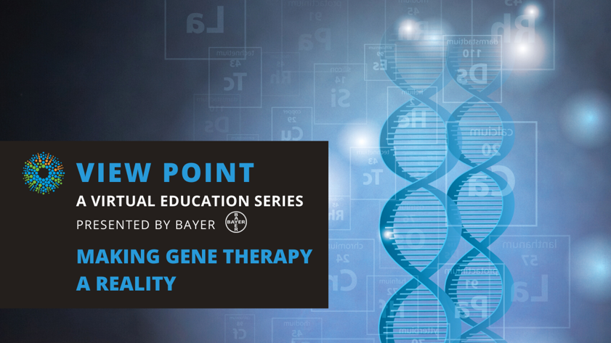
Making Gene Therapy a Reality
Tuesday, April 13, 2021, 3:30 p.m. ET
Community Showcase
For the first half hour of the webinar, we will provide an overview of the Fighting Blindness Canada Patient Registry: what it is, what it means for vision research in Canada, and how you can get involved.
Guest Speaker
2020 was an exciting year as the first gene therapy for an eye disease was approved by Health Canada. In this webinar, join Dr. Cynthia Qian as we discuss all things gene therapy: what it is, how it works, what’s new, and what’s next.
There will be a question and answer period at the end of the webinar. Questions can be emailed in advance to education@fightingblindness.ca or shared during the question period.

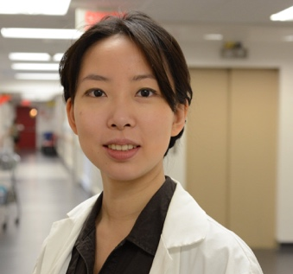
ABOUT THE SPEAKER: DR. CYNTHIA QIAN
Dr. Cynthia Qian is a professor in the Department of Ophthalmology and the head of the electrophysiology laboratory, the inherited retinal diseases service, and the pediatric retina service at the University of Montreal. She is the current Vice President of the Canadian Retina Society and the Quebec representative for ophthalmology on the Royal College nucleus committee.

She is an expert on pathologies of the pediatric retina and on retinal dystrophy, particularly on the surgical implantation of retinal prostheses and subretinal gene therapy. She successfully implanted the first retinal prosthesis in Quebec with her colleague Dr. Flavio Rezende in 2017. Currently she is the main clinician evaluating potential candidates for the RPE65 genetic mutation Luxturna treatment and will be one of the two surgeons performing the surgery in the province of Quebec.

She is a spokesperson for the Canadian Ophthalmology Society (COS) and has been recognized for her groundbreaking work both as a leader in medicine and as a rising star in clinical ophthalmology. She was chosen as the Young Physician Leaders delegate to represent Canada at the World Health Summit in 2017. She has also been voted as “The Young Professional of the Year” by the Young Chamber of Commerce of Montreal in 2018 and as one of Canada’s Top 40 under 40 in 2019.

Support View Point
Now more than ever, we need your support! View Point is free of charge for all participants. If you would like to support this program and the important sight-saving research funded by Fighting Blindness Canada, please make a donation today!

FBC Health Information Line
Our Health Information Lines provides the vision loss community with someone to ask their vision health questions. If you have questions about your eye health, please call 1-888-626-2995 or email healthinfo@fightingblindness.ca

THANK YOU TO OUR SPONSORS
