WELCOME TO VIEW POINT

Welcome to View Point, Fighting Blindness Canada’s virtual education series that brings the latest in vision research directly to you at home. In 2021, View Point will present topics including age-related macular degneration, glaucoma, gene therapy, caregiving, inherited retinal disease, cateracts, and diabetic eye disease.

To keep up-to-date on upcoming webinars, and access past View Point recordings, please visit our virtual education web page.

If you would like to receive email updates about new View Point webinars or to suggest future webinar topics, please email education@fightingblindness.ca.

WEBINAR PROGRAM
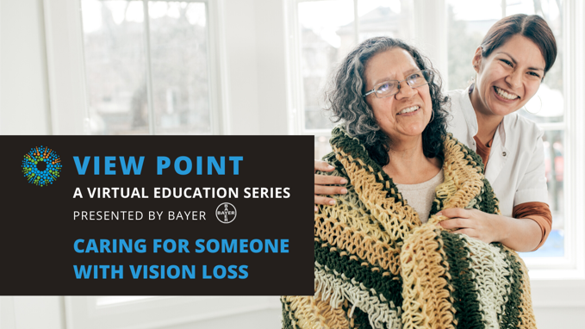
Making Gene Therapy a Reality
Tuesday, April 13, 2021, 3:30 p.m. ET

Caregivers and the loved ones they support are a diverse community. They include parents, children, partners, and siblings among others. Caregivers provide essential physical, emotional, and financial support. However, they are often a silent partner and their needs are often overlooked and unknown. In this panel discussion, we will discuss the joys and struggles of caring for a loved one with vision loss.

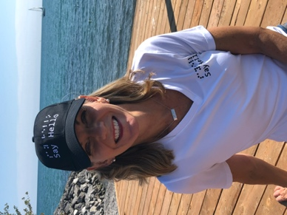
FEATURED COMMUNITY SHOWCASE
We will be joined by Denise Justin from Say Hello 2 Blindness, to learn more about her story. Denise lives with Stargardt disease and is a long-time FBC supporter and monthly donor. Denise promotes vision loss awareness with style – selling clothing, accessories, jewelry and bags branded with her signature “Say Hello” in print and braille. For the month of May, Denise is kindly offering 15% off Say Hello products! No discount code needed. You can learn more and order from the Say Hello brand at https://sayhello2blindness.com/
There will be a question and answer period at the end of the webinar. Questions can be emailed in advance to education@fightingblindness.ca or shared during the question period.

ABOUT THE SPEAKERS
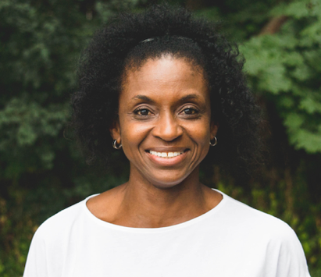
Charmain Brown is a dedicated educator with twenty-five years of teaching and leadership experience with the York Region District School Board. She has an extensive background in curriculum, instruction, equity, and inclusion. Charmain has been a co-writer on numerous publications and resources focused on various equity issues, including the book Possibilities: Addressing Poverty in Elementary Schools, and currently teaches at the Faculties of Education at York University and Tyndale University. She is the mother of two incredible young people that both live with a visual impairment, and is an ally for the vision loss community particularly in educational spaces.

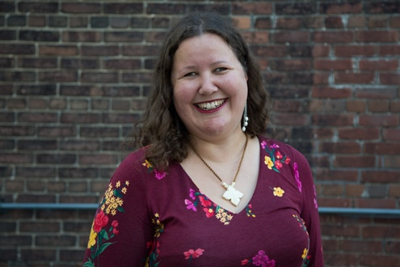
Lisa Derencinovic, MSW, RSW has been a Counsellor since 2012. Lisa earned her Bachelors and Masters degrees in Social Work from Ryerson University. Her specialties include working with women, grief and loss, general wellness, and living with a disability. Lisa brings an anti-oppressive lens to her work, connecting individual experiences to the broader society. She uses elements of mindfulness, narrative therapy, cognitive behavioural therapy (CBT), and a strengths based approach.

Lisa lives with a genetic eye disease and use a white mobility cane. Vision loss has not stopped Lisa from making world famous eggplant lasagna or completing a half marathon! She also loves to dance, read fiction, and spend time snuggling with her cat.

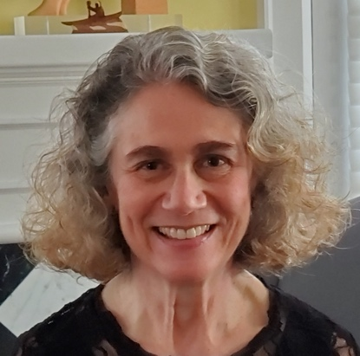
Toby Rose MD FRCPC was the Deputy Chief Forensic Pathologist of the Ontario Forensic Pathology Service from 2011-2018 and continues to work as a forensic pathologist at the Provincial Forensic Pathology Unit in Toronto. She received her medical training at the University of Saskatchewan and University of Toronto. She is Emerita Associate Professor of Laboratory Medicine and Pathobiology (Pathology) at U of T. She is married with three sons and one grandson. Toby’s mother lives with age-related macular degeneration (AMD), as did both her maternal grandparents.

Support View Point
Now more than ever, we need your support! View Point is free of charge for all participants. If you would like to support this program and the important sight-saving research funded by Fighting Blindness Canada, please make a donation today!

FBC Health Information Line
Our Health Information Lines provides the vision loss community with someone to ask their vision health questions. If you have questions about your eye health, please call 1-888-626-2995 or email healthinfo@fightingblindness.ca

THANK YOU TO OUR SPONSORS
