WELCOME TO VIEW POINT

Welcome to View Point, Fighting Blindness Canada’s virtual education series that brings the latest in vision research directly to you at home. In 2021, View Point will present topics including age-related macular degneration, glaucoma, gene therapy, caregiving, inherited retinal disease, cateracts, and diabetic eye disease.

To keep up-to-date on upcoming webinars, and access past View Point recordings, please visit our virtual education web page.

If you would like to receive email updates about new View Point webinars or to suggest future webinar topics, please email education@fightingblindness.ca.

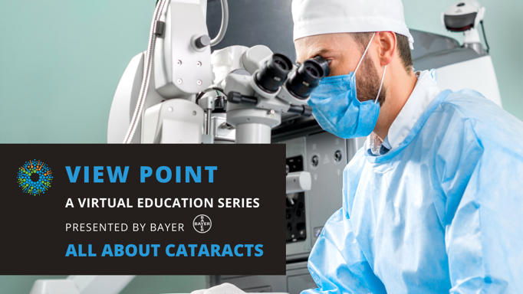
WEBINAR PROGRAM
All About Cataracts
Tuesday, June 29, 2021, 3:30 – 5:00 pm ET
Did you know that June is Cataracts Awareness Month? This month, join FBC to learn all about the world’s leading cause of treatable blindness.
Cataracts occur when the lens of the eye develops cloudy patches. These changes to the eye can cause vision loss and if left untreated, blindness. Cataracts are most commonly associated with aging, but can affect people at any age. In this webinar, Dr. Amandeep S. Rai will discuss what cataracts are, how they can affect you and what treatments are available.
There will be a question and answer period at the end of the webinar. Questions can be emailed in advance to education@fightingblindness.ca or shared during the question period.

FEATURED COMMUNITY SHOWCASE
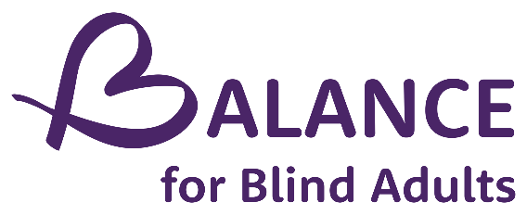
BALANCE for Blind Adults is a not-for-profit with more than 30 years experience working with individuals who are blind or partially sighted. Their programs enable people with sight loss to live with dignity and inclusion, and to lead independent, active lifestyles. While based in the Greater Toronto Area, BALANCE has a wide variety of virtual programs that are open to people across Canada.

ABOUT THE SPEAKER

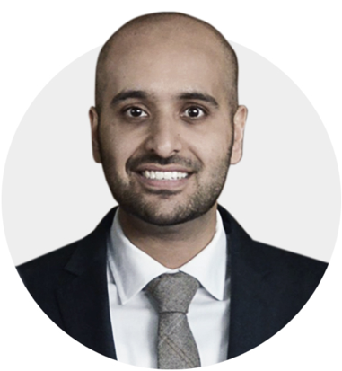
Dr. Amandeep S. Rai MD FRCSC is a comprehensive ophthalmologist with an interest in cataract surgery. He's an active faculty member of the Department of Ophthalmology & Vision Sciences at the University of Toronto, and serves as the Associate Program Director for the ophthalmology residency program. He is a leader in medical education and is the co-director of the national Toronto Ophthalmology Residents Introductory Course (TORIC), and a founding member of the senior residents course, All About IOLs.

Dr. Rai is a highly regarded cataract surgeon with an interest in intraocular lens design, biometry, and complex cataract surgery. He is a co-director of the highly regarded annual Toronto Cataract Course. He also coordinates the award winning University of Toronto Resident Cataract Clinic at the Kensington Eye Institute. Dr. Rai leads a team of Toronto ophthalmologists and ophthalmology residents on an annual collaborative outreach trip to rural Costa Rica, working alongside and arranging teaching for residents and faculty from the University of Costa Rica.

Support View Point
Now more than ever, we need your support! View Point is free of charge for all participants. If you would like to support this program and the important sight-saving research funded by Fighting Blindness Canada, please make a donation today!

FBC Health Information Line
Our Health Information Lines provides the vision loss community with someone to ask their vision health questions. If you have questions about your eye health, please call 1-888-626-2995 or email healthinfo@fightingblindness.ca

THANK YOU TO OUR SPONSORS
