WELCOME TO VIEW POINT

Welcome to View Point, Fighting Blindness Canada’s virtual education series that brings the latest in vision research directly to you at home. In 2021, View Point will present topics including age-related macular degneration, glaucoma, gene therapy, caregiving, inherited retinal disease, cateracts, and diabetic eye disease.

To keep up-to-date on upcoming webinars, and access past View Point recordings, please visit our virtual education web page.

If you would like to receive email updates about new View Point webinars or to suggest future webinar topics, please email education@fightingblindness.ca.

WEBINAR PROGRAM
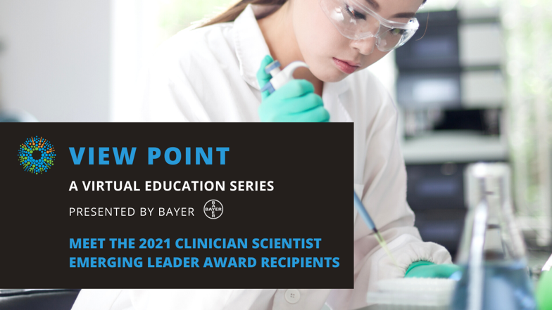
Spotlight on CSEL: Meet the 2021 Recipients of FBC’s Clinician-Scientist Emerging Leader Award
Tuesday, July 27, 2021, 4 – 5:30 p.m. ET

In this webinar we will hear from the three recipients of FBC’s 2021 Clinician-Scientist emerging leader award. Join us to learn more about their exciting research projects and ask your questions about the future of vision research.

Featured scientists:
Dr. Tina Felfeli: Developing a better way to diagnose and manage non-infectious uveitis
Dr. Delphine Gobert: Investigating the role of microglia in diabetic retinopathy
Dr. Stephan Ong-Tone: Testing virus-mediated gene therapy to treat Fuchs Endothelial Corneal Dystrophy (FECD)

There will be a question and answer period at the end of the webinar. Questions can be emailed in advance to education@fightingblindness.ca or shared during the question period.

ABOUT THE SPEAKERS
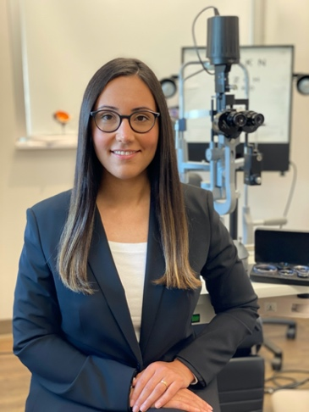
Dr. Tina Felfeli is a resident physician in the Department of Ophthalmology and Vision Sciences at University of Toronto. She completed her medical school training at University of Toronto where she received the J. P. Boley Prize in Ophthalmology for the highest academic standing in her graduating class. Currently, she is completing a PhD degree in Clinical Epidemiology at the Institute of Health Policy, Management and Evaluation, Dalla Lana School of Public Health, University of Toronto as a part of the Integrated Physician-Scientist program. Dr. Felfeli's research interests include application of prediction models for uveitis, retinal diseases, and evaluation of health care delivery within the field of ophthalmology.

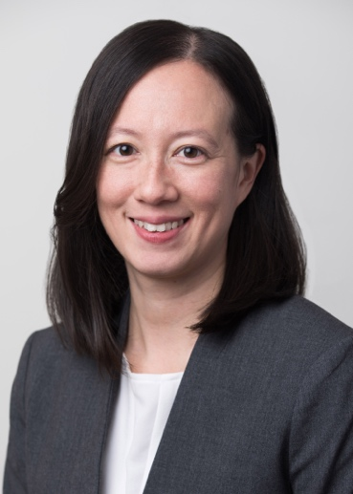
Dr. Delphine Gobert has always been fascinated by the nervous system and understanding how it can process information. After earning her undergraduate degree in Biomedical Science, Dr. Gobert completed graduate studies at Université de Montréal and a postdoctoral fellowship in Neuroscience at McGill University, which was the perfect opportunity to deepen her understanding of the brain. During those years, she studied developmental plasticity and circuit formation in the visual system in vivo and developed a keen interest in ophthalmology, which continued to expand in medical school. After having completed medical school at McGill University, Dr. Gobert is now enrolled as a second-year resident in ophthalmology at Université Laval.

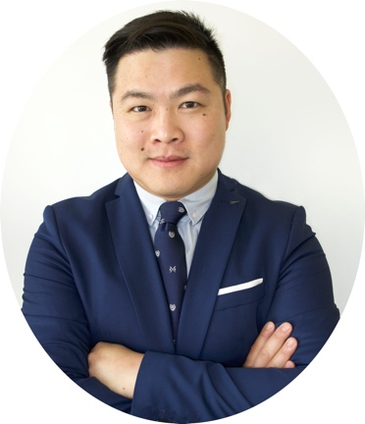
Dr. Ong Tone is an early career researcher and clinician-scientist at Sunnybrook Health Sciences Centre & Sunnybrook Research Institute. He completed the MDCM-PhD joint program at McGill University in 2013, with a PhD in Neurological Sciences. He then completed his residency in Ophthalmology at the University of Toronto in 2018, where he served as Co-Chief Resident. To continue his career development as a clinician-scientist, he completed a 2-year clinical-research fellowship in Cornea, External Disease and Refractive Surgery at Massachusetts Eye and Ear, Harvard Medical School in July 2020. During his clinical-research fellowship, in addition to his clinical training as a Cornea specialist, he performed basic science research on Fuchs endothelial corneal dystrophy (FECD). To date, he has published 28 peer-reviewed manuscripts, including 16 first author/senior author publications, and 1 book chapter. Collectively, his research projects will expand the foundational knowledge of normal corneal endothelial cell biology and the pathological changes that occur in FECD.

Support View Point
Now more than ever, we need your support! View Point is free of charge for all participants. If you would like to support this program and the important sight-saving research funded by Fighting Blindness Canada, please make a donation today!

FBC Health Information Line
Our Health Information Lines provides the vision loss community with someone to ask their vision health questions. If you have questions about your eye health, please call 1-888-626-2995 or email healthinfo@fightingblindness.ca

THANK YOU TO OUR 2021 CSEL AWARD SPONSORS
The 2021 CSEL Awards have been made possible through the generous support of Andrew and Valerie Pringle, Dr. Peter Kertes, the Bank of Montreal (BMO), and Bayer Inc.

THANK YOU TO OUR VIEW POINT SPONSORS
