WELCOME TO VIEW POINT

Welcome to View Point, Fighting Blindness Canada’s virtual education series that brings the latest in vision research directly to you at home. In 2021, View Point will present topics including age-related macular degneration, glaucoma, gene therapy, caregiving, inherited retinal disease, cateracts, and diabetic eye disease.

To keep up-to-date on upcoming webinars, and access past View Point recordings, please visit our virtual education web page.

If you would like to receive email updates about new View Point webinars or to suggest future webinar topics, please email education@fightingblindness.ca.

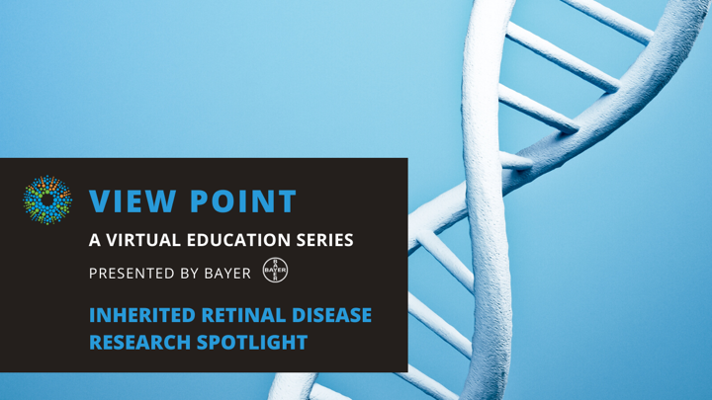
WEBINAR PROGRAM
Inherited Retinal Disease Research Spotlight
Tuesday, September 14, 2021, 3 – 4:30 p.m. ET
An inherited retinal disease (IRD) is a condition caused by a specific genetic mutation. In this webinar, we will hear from scientists who are studying this family of conditions that cause retinal damage and vision loss. Join us to learn from the experts about research on Stargardt disease, retinitis pigmentosa, and Usher syndrome. Featured scientists include Dr. Rod Bremner, Dr. Bob Chow, and Dr. Vincent Tropepe.
There will be a question and answer period at the end of the webinar. Questions can be emailed in advance to education@fightingblindness.ca or shared during the question period.

ABOUT THE SPEAKERS

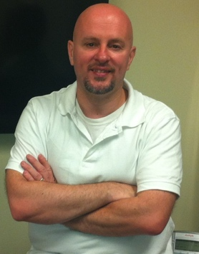
Dr. Rod Bremner obtained a Biochemistry degree in Aberdeen, a Ph.D. in the Beatson Institute for Cancer Research in Glasgow, and then did a post-doctoral fellowship at Sickkids Hospital in Toronto. He started his own lab in 1994 at the Toronto Western Hospital, and moved to the Lunenfeld Tanenbaum Research Institute (LTRI) at Mt Sinai Hospital in 2013. He’s a senior scientist, a professor at U Toronto in the Department of Ophthalmology and Vision Science, and holds the Freiberg Cancer Research Chair at LTRI. Rod’s initial interest in the retina started from his work on the retinoblastoma tumor suppressor gene (RB1). RB1 gene loss causes the childhood eye cancer retinoblastoma. To understand that disease, his lab became expert in retinal development, and that journey sparked a long-term interest in retinitis pigmentosa (RP). Many groups in the cancer field have used CRISPR, which allows gene editing, to identify genes that influence that group of diseases. Now, together with Daniel Schramek’s team at LTRI, the Bremner lab is developing tools to apply CRISPR to find genes that trigger the loss of photoreceptors and thus drive RP and blindness. Deducing these cell death drivers will expose new strategies to prevent photoreceptor loss and retain vision.
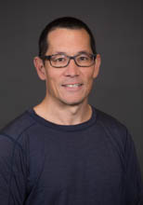
Dr. Bob Chow received his BSc from the University of Toronto and his PhD from NYU. He did his postdoc at the Hospital for Sick Children and is currently a faculty member at the University of Victoria in the Department of Biology. Dr. Chow’s research is focused on understanding mechanisms that underlie neural development. His lab is primarily interested in gene regulation during retinal development, and how it directs formation of the many different cell types that make up the retina. Much of his research is also focused on genes involved in eye disease. This includes current work on Pax6, a gene that is responsible for ocular disease, aniridia. In addition, his lab was awarded a grant from FBC this year to initiate work on Stargardt disease. Bob currently is a member of FBC’s Scientific Advisory Committee.

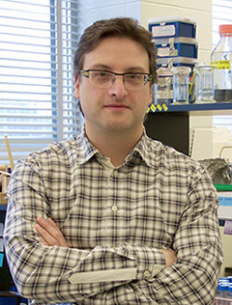
Dr. Vince Tropepe Dr. Tropepe received his Honours B.Sc, in Biology & Psychology at McMaster University and his Ph.D. in the Collaborative Program in Developmental Biology at the University of Toronto where he studied neural stem cells in the developing and adult mouse brain and retina. He completed a CIHR postdoctoral fellowship at the Whitehead Institute, MIT, where he investigated the transcriptional regulation of neural induction and brain pattering in Xenopus and zebrafish. He is currently a Full Professor in the Departments of Cell & Systems Biology with a cross-appointment in the Department of Ophthalmology & Vision Sciences. Since July 2020 he has been serving as Vice-Dean of Research in the Faculty of Arts & Science at the University of Toronto. His research interests are focused on the molecular and cellular mechanisms of neurogenesis in relation to development, plasticity, and disease.
Support View Point
Now more than ever, we need your support! View Point is free of charge for all participants. If you would like to support this program and the important sight-saving research funded by Fighting Blindness Canada, please make a donation today!

FBC Health Information Line
Our Health Information Lines provides the vision loss community with someone to ask their vision health questions. If you have questions about your eye health, please call 1-888-626-2995 or email healthinfo@fightingblindness.ca

THANK YOU TO OUR VIEW POINT SPONSORS
