WELCOME TO VIEW POINT

Welcome to View Point, Fighting Blindness Canada’s virtual education series that brings the latest in vision research directly to you at home. This year, View Point will present topics including age-related macular degeneration, glaucoma, gene therapy, caregiving, inherited retinal disease, cataracts, and diabetic eye disease.

To keep up-to-date on upcoming webinars, and access past View Point recordings, please visit our virtual education web page.

If you would like to receive email updates about new View Point webinars or to suggest future webinar topics, please email education@fightingblindness.ca.

WEBINAR PROGRAM

Diabetic Vision Loss: Prevention & Management
Wednesday, November 24, 2021, 4 pm – 5:30 pm ET
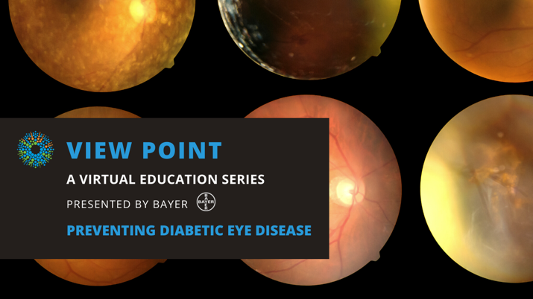
Did you know that one in three Canadians live with diabetes or pre-diabetes? Diabetes can cause uncontrolled bleeding in the retina, putting people with diabetes at risk of losing their eyesight. Join FBC this month for Diabetes Awareness month to find out more about how diabetes can affect your vision.
In this informative session, Dr. Bernard Hurley will talk about steps you can take to prevent diabetic eye complications and Kim Barwise will speak to her lived experience of managing her diabetes. If you are affected by diabetic retinopathy or diabetic macular edema (DME) strategies for managing these conditions will also be discussed
There will also be a Q&A period at the end of the webinar. Questions can be emailed in advance to education@fightingblindness.ca or shared during the question period.

ABOUT THE SPEAKERS

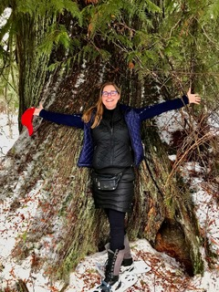
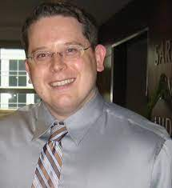
Dr. Bernard R. Hurley, BSc, MD, FRCSC is an Assistant Professor at The University of Ottawa Eye Institute where he is also the residency program director and the fellowship program director. He has received awards for top clinical instruction in the department in 2016, 2013 and 2011. He completed his post-graduate medical education with a Retina Fellowship at the Wills Eye Hospital in Philadelphia where he was twice awarded the Outstanding Fellow Award. He has written several chapters and has been the author or co-author of many peer-reviewed publications on topics including diabetic retinopathy and age-related macular degeneration. He has received research support from the E.A. Baker Foundation.
Kim Barwise is a retired nurse living with Type 1 diabetes. She was a diabetes nurse educator for 14 years. Following the birth of her 2nd daughter she went on to produce 2 educational films to help raise awareness for Stickler Syndrome, a connective tissue condition affecting the eyes, joints, and face. One of the consequences of Stickler Syndrome can be blindness. Kim continues to be passionate about self-advocacy and speaking informally to people with diabetes based on her lived experience. In her spare time, she is learning Spanish and music composition piano. Her moto has always been, get the most out of life regardless of what it throws at you.

Support View Point
Now more than ever, we need your support! View Point is free of charge for all participants. If you would like to support this program and the important sight-saving research funded by Fighting Blindness Canada, please make a donation today!

FBC Health Information Line
Our Health Information Lines provides the vision loss community with someone to ask their vision health questions. If you have questions about your eye health, please call 1-888-626-2995 or email healthinfo@fightingblindness.ca

THANK YOU TO OUR VIEW POINT SPONSORS
