WELCOME TO VIEW POINT

Welcome to View Point, Fighting Blindness Canada’s virtual education series that brings you the latest information about vision health and research. 2022 topics will include new research projects, AMD, glaucoma, optogenetics and much more!

To keep up-to-date on upcoming webinars, and access past View Point recordings, please visit our virtual education web page.

If you would like to receive email updates about new View Point webinars or to suggest future webinar topics, please email education@fightingblindness.ca.

WEBINAR PROGRAM
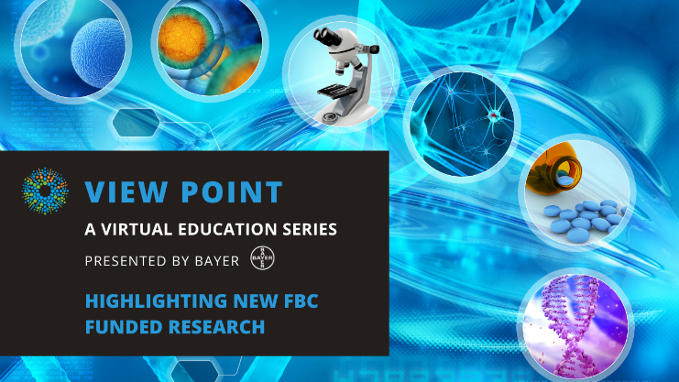
Highlighting New FBC Funded Research
Tuesday, January 25, 2022, 3 pm – 4:30 pm
Fighting Blindness Canada is starting the new year with an exciting research announcement! We are pleased to share that we will be funding 8 innovative research awards from our 2021 Research Grant Competition.

In this webinar, Dr. Larissa Moniz, FBC’s Director of Research and Mission Programs will talk about the grant review process and highlight the 8 new projects.

We will also be joined by three of the funded researchers to hear more about their projects.

- Dr. Anna Ells: Setting up a retinopathy of prematurity treatment database
- Dr. Michael Salman: Identifying risk factors for septo-optic dysplasia and optic nerve hypoplasia
- Dr. Ajitha Thanabalasuriar: Understanding the interplay between bacteria and immune cells in corneal infection

There will be a question and answer period at the end of the webinar. Questions can be emailed in advance to education@fightingblindness.ca or shared during the question period.

ABOUT THE SPEAKERS
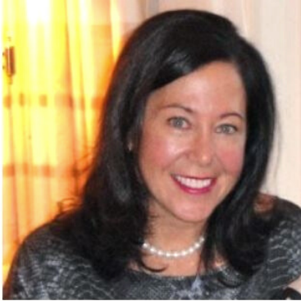
Dr. Anna Ells earned her MD degree from The University of Ottawa and received her ophthalmology residency training at the University of Ottawa and specialized fellowship training in Pediatric Ophthalmology at The Hospital for Sick Children, and in Medical Retina at the University of Calgary. She is a Professor of Ophthalmology at the University of Calgary, as well as an adjunct professor at the Schulich School of Engineering Department of Electrical and Computer Engineering at the University of Calgary. In addition to her busy practice and surgical schedule, Dr. Ells is an active and accomplished researcher, lecturer, and teacher.

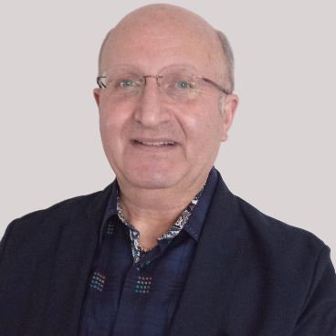
Dr. Michael Salman is a pediatric neurologist and neuro-ophthalmologist. He obtained his medical degree in the UK at the University of London. He finished his training in pediatrics and then undertook further specialization in pediatric neurology in the UK. He completed his fellowship training in pediatric neurology at the Hospital for Sick Children in Toronto. He then did a fellowship in neuro-ophthalmology at Toronto Western Hospital/University Health Network and a clinician-scientist/PhD program at the Institute of Medical Science at the University of Toronto, before starting at the University of Manitoba, where he is an associate professor. The goals of Dr. Salman’s research program are to find modifiable risk factors for SOD and ONH, which may help reduce the incidence of these conditions, and also to contribute to future research that could one day reveal treatment options.

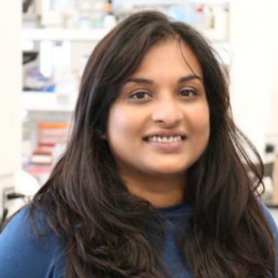
Dr. Ajitha Thanabalasuriar is an Assistant Professor in the department of Pharmacology and Therpeutics at McGill University. She completed her PhD in Bacterial Pathogenesis at McGill Universtiy, and completed a postdoctoral fellowship at the University of Calgary. She is currently the Canada Research Chair in Infection, Immunity, and Targeted Drug Therapies. The goals of Dr. Thanabalasuriar’s research program are to identify the mechanisms by which biofilms develop, and ultimately, to reveal alternative drug targets that may help prevent bacterial keratitis, reduced vision acuity, and blindness.

Support View Point
Now more than ever, we need your support! View Point is free of charge for all participants. If you would like to support this program and the important sight-saving research funded by Fighting Blindness Canada, please make a donation today!

FBC Health Information Line
Our Health Information Line provides the vision loss community with someone to ask their vision health questions. If you have questions about your eye health, please call 1-888-626-2995 or email healthinfo@fightingblindness.ca

THANK YOU TO OUR VIEW POINT SPONSORS
