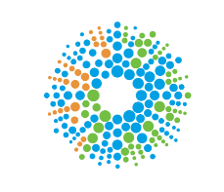
WELCOME TO VIEW POINT

Welcome to View Point, Fighting Blindness Canada’s virtual education series that brings you the latest information about vision health and research. 2022 topics will include new research projects, AMD, glaucoma, optogenetics and much more!

To keep up-to-date on upcoming webinars, and access past View Point recordings, please visit our virtual education web page.

If you would like to receive email updates about new View Point webinars or to suggest future webinar topics, please email education@fightingblindness.ca.

WEBINAR PROGRAM

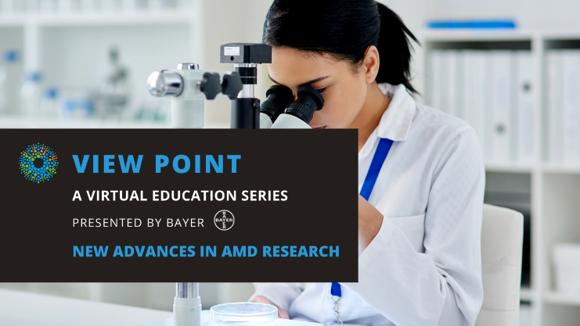
Advances in AMD Research
Wednesday, February 23, 2022
3 pm – 4:30 pm

Age-related macular degeneration (AMD) is the leading cause of vision loss in people over the age of 50, affecting approximately 2.5 million Canadians. This February, join us for AMD Awareness Month and a special roundtable highlighting new developments in AMD research & treatments.

In this webinar we will be joined by three speakers who will cover the following topics:

- Dr. Levi Blazer will speak about an FBC-funded research project that is looking at a new recombinant antibody treatment for AMD.
- Dr. Bernie Hurley will discuss a new class of drugs called “biosimilars” and will describe how they will impact AMD patients.
- Dr. Peter Kertes will share information about new research into dry AMD and geographic atrophy.

There will be a question and answer period at the end of the webinar. Questions can be emailed in advance to education@fightingblindness.ca or shared during the question period.

ABOUT THE SPEAKERS

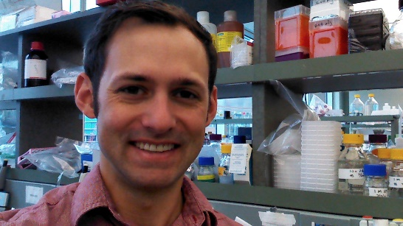
Dr. Levi Blazer has over 10 years’ experience in drug discovery and has spent over 15 years in scientific research. He obtained his Ph.D. in Pharmacology from the University of Michigan, Ann Arbor, MI, USA, where he developed the first reversible inhibitors of the Regulator of G-protein Signaling (RGS) proteins. He continued his small molecule drug discovery career in the Molecular Screening department at Cayman Chemical in Ann Arbor, MI. After observing the immense potential of recombinant antibodies, Levi shifted focus from small molecules to biologics and joined the Toronto Recombinant Antibody Centre (TRAC). There he studied antibody engineering under the guidance of Professor Sachdev Sidhu, specifically focusing on multivalent antibody modalities with a special emphasis on antibody ‘developability.’ Levi has published 27 articles in peer-reviewed journals including eLife and Nature Communications and holds two patents.

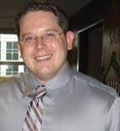
Dr. Bernie Hurley, BSc, MD, FRCSC is an Assistant Professor at The University of Ottawa Eye Institute where he is also the residency program director and the fellowship program director. He has received awards for top clinical instruction in the department in 2016, 2013 and 2011. He completed his post-graduate medical education with a Retina Fellowship at the Wills Eye Hospital in Philadelphia where he was twice awarded the Outstanding Fellow Award. He has written several chapters and has been the author or co-author of many peer-reviewed publications on topics including diabetic retinopathy and age-related macular degeneration. He has received research support from the E.A. Baker Foundation.

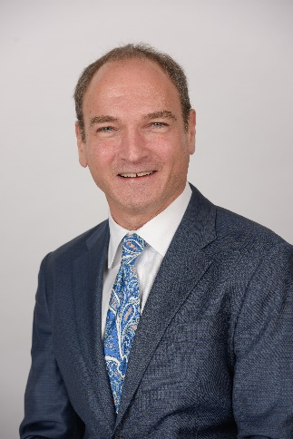
Dr. Peter Kertes majored in Molecular Biology at Princeton University as an undergraduate and went to McGill University for Medical School. He then did a residency in Ophthalmology at the University of Ottawa and undertook a 2 year vitreo-retinal surgical fellowship with Dr. Gholam Peyman at Louisiana State University in New Orleans, LA. In practice in Ottawa starting in 1997, Dr. Kertes then moved to the Sunnybrook Health Sciences Centre in Toronto in 2003 where he is currently a vitreoretinal surgeon. He was the Ophthalmologist-in-chief of the John and Liz Tory Eye Centre at Sunnybrook from 2010 to 2021, and on staff at the Hospital for Sick Children. Dr. Kertes is also a Professor of Ophthalmology and Vision Sciences at the University of Toronto. He has an interest in clinical epidemiology and evidence-based medicine and has published 3 books on the major clinical trials in Ophthalmology.

Support View Point
Now more than ever, we need your support! View Point is free of charge for all participants. If you would like to support this program and the important sight-saving research funded by Fighting Blindness Canada, please make a donation today!

FBC Health Information Line
Our Health Information Line provides the vision loss community with someone to ask their vision health questions. If you have questions about your eye health, please call 1-888-626-2995 or email healthinfo@fightingblindness.ca

THANK YOU TO OUR VIEW POINT SPONSORS
