# **Image of FBC branded iris logo visual WELCOME TO VIEW POINT**

Welcome to View Point, Fighting Blindness Canada’s virtual education series that brings you the latest information about vision health and research. 2022 topics will include new research projects, AMD, glaucoma, optogenetics and much more!

To keep up-to-date on upcoming webinars, and access past View Point recordings, please visit our [virtual education web page](https://www.fightingblindness.ca/events/virtual-events/).

If you would like to receive email updates about new View Point webinars or to suggest future webinar topics, please email [education@fightingblindness.ca](mailto:education@fightingblindness.ca).

# **WEBINAR PROGRAM**

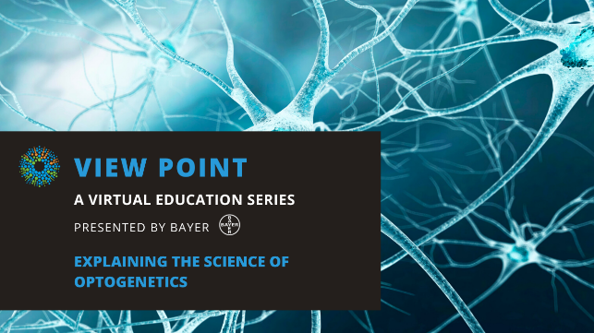**Explaining the Science of Optogenetics  
Wednesday, March 23, 2022**

**3 pm – 4:30 pm**

Optogenetics is an exciting new avenue of vision research! In this experimental technique, DNA is inserted into cells into the eye to transform them into light-sensitive cells. The benefit of this approach is that it has the potential to restore sight in people who have lost all photoreceptors.

In this webinar we will be joined by three speakers who will cover the following topics:

* **Dr. Brian Ballios** will join us to explain the basic science of optogenetics
* **Dr. Julie Lefebvre** and **Dr. Arjun Krishnaswamy** will share information about their exciting new FBC-funded research project including their plans and the potential of this cutting-edge treatment.

There will be a question and answer period at the end of the webinar. Questions can be emailed in advance to [education@fightingblindness.ca](mailto:education@fightingblindness.ca) or shared during the question period.

# **ABOUT THE SPEAKERS**

**Dr. Brian Ballios** is a fellowship-trained clinician-scientist, with a focus on medical retinal disease and a subspecialty in inherited retinal disease. He is an Assistant Professor in the Department of Ophthalmology and Vision Sciences at the University of Toronto. He holds appointment as clinician-scientist at the University Health Network in the Donald K. Johnson Eye Institute, and is a staff physician at Sunnybrook Health Sciences Centre, and the Kensington Vision and Research Centre. He is a Scientist at the Krembil Research Institute where he has a laboratory investigating the mechanisms of acquired and inherited retinal disease, and the development of new stem cell-based therapies.

Dr. Ballios obtained his MD and PhD degrees at the University of Toronto in the combined MD/PhD program. With a background in material science and Engineering Chemistry (Queen’s University), his doctoral work focused on new approaches to the transplantation of stem cells and their progeny for the treatment of retinal degeneration. After completing his FRCSC in Ophthalmology at the University of Toronto, he undertook a subspecialty clinical fellowship in Inherited Retinal Disease at Massachusetts Eye and Ear and Harvard University.

**Dr. Arjun Krishnaswamy** is an Assistant Professor in the Department of Physiology at McGill University and a member of the Cell Information Systems group at the Life Sciences Complex. He earned his PhD at McGill and completed postdoctoral training at Harvard University. He was a finalist for the 2016 Eppendorf&Science prize in neurobiology and was awarded a Canada Research Chair in neural circuit assembly and function in 2017. In 2019, he was awarded a Sloan Fellowship in Neuroscience by the Alfred P. Sloan Foundation. Krishnaswamy's lab seeks to identify the molecular blueprints that specify wiring patterns in neural circuits and link these patterns to circuit function. To do this, his lab employs molecular-genetic methods to learn how neurons in the retina and its immediate targets within the brain wire specifically and create visual-feature detecting circuits. The lab uses several tools including molecular-genetics, optogenetics, in vivo imaging, behavioral approaches, and eletrophysiology.

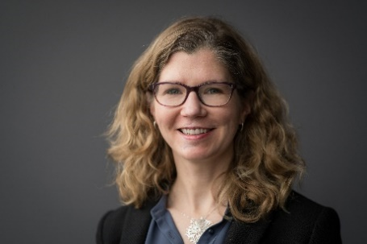**Dr. Julie Lefebvre** is a Senior Scientist in the Neurosciences and Mental Health Program at The Hospital for Sick Children, and an Assistant Professor of the Department of Molecular Genetics at the University of Toronto. She earned her PhD at the University of Pennsylvania, and completed her postdoctoral research training at Harvard University. In 2014 and 2019, she was Canada Research Chair in Neural Circuit Development. In 2015, she was awarded a Sloan Fellowship in Neuroscience by the Alfred P. Sloan Foundation. The research focus of the Lefebvre lab is to understand how nerve cells develop and wire up into neural circuits, and to determine what goes wrong in the formation and function of these neural connections in disease. Her lab studies these questions in the retina of mouse models using a variety of transgenic, molecular and microscopy tools. They have also developed technologies to examine how remaining neural connections can be harnessed in spite of photoreceptor degeneration, and to track the formation of new connections following experimental cell transplantations.

**Support View Point**

Now more than ever, we need your support! View Point is free of charge for all participants. If you would like to support this program and the important sight-saving research funded by Fighting Blindness Canada, please [**make a donation today**](https://fightingblindness.donorportal.ca/Donation/Donation.aspx?F=1689&T=GENER&L=en-CA&G=307&NFP=1&_ga=2.219803929.1651576222.1590498661-475951419.1582852242)!

# **FBC Health Information Line**

Our Health Information Line provides the vision loss community with someone to ask their vision health questions. If you have questions about your eye health, please call **1-888-626-2995** or email [**healthinfo@fightingblindness.ca**](mailto:healthinfo@fightingblindness.ca)

# **THANK YOU TO OUR VIEW POINT SPONSORS**

