WELCOME TO VIEW POINT

Welcome to View Point, Fighting Blindness Canada’s virtual education series that brings you the latest information about vision health and research. 2022 topics will include new research projects, AMD, glaucoma, optogenetics and much more!

To keep up-to-date on upcoming webinars, and access past View Point recordings, please visit our virtual education web page.

If you would like to receive email updates about new View Point webinars or to suggest future webinar topics, please email education@fightingblindness.ca.

EVENT PROGRAM

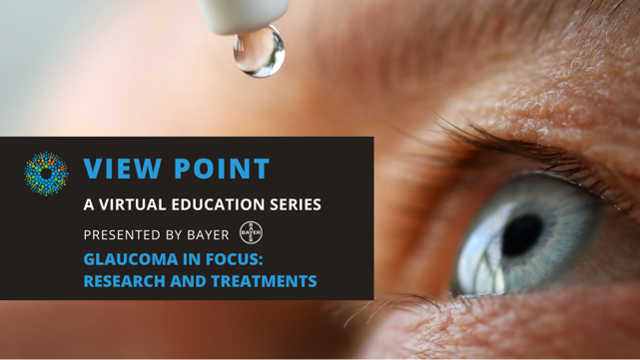
Glaucoma in Focus: Research & Treatments
Tuesday, April 12th, 2022
3:00 pm – 4:30 pm ET
Join us for a special webinar all about glaucoma. We will be joined by two experts to learn more about this disease that affects more than 728,000 Canadians.
In the first half of the session, Dr. Balwantray Chauhan will speak about his new FBC-funded research project that aims to develop an imaging technique that will measure optic nerve damage in glaucoma. Dr. Raageen Kanjee will join us for the second part of the webinar where he will give us an overview of glaucoma drops: what types there are, how they treat glaucoma, how you can safely administer them and what new research is happening now.
There will be time for Q&A. If you have questions in advance or need any assistance with registration, please email education@fightingblindness.ca

ABOUT THE SPEAKERS

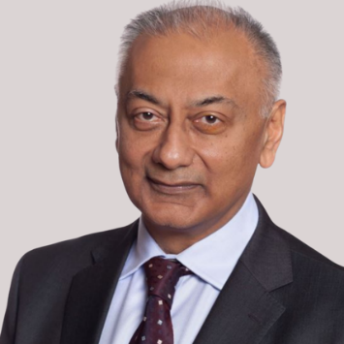
Dr Balwantray Chauhan is the Mathers Professor and Research Director of Ophthalmology and Visual Sciences, and Professor of Physiology and Biophysics at Dalhousie University. He obtained his PhD at the University of Wales (UK) and completed postdoctoral training at the University of British Columbia.

Dr. Chauhan’s research interests center on changes in the visual field and optic nerve in glaucoma. He has devised new strategies for detecting glaucoma progression and conducted research leading to their translation to clinical practice. This research is conducted in the Retina and Optic Nerve Research Laboratory, a multidisciplinary facility he was instrumental in establishing. Dr. Chauhan is also Principal Investigator of the Canadian Glaucoma Study, a multicenter study on the risk factors for progression of open-angle glaucoma.
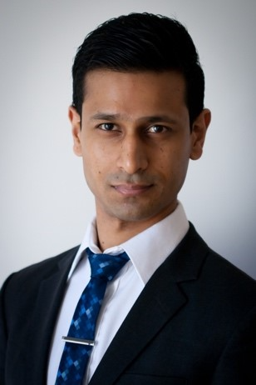
Dr Raageen Kanjee graduated from medical school at the University of Toronto and subsequently completed residency training in ophthalmology at the University of Manitoba. He then went on to complete a fellowship in glaucoma at McGill University before returning to Winnipeg. He specializes in glaucoma and cataracts, and is actively involved in training medical students, residents, and fellows. Dr Kanjee has been an invited speaker nationally and has authored several peer-reviewed articles and book chapters.

Support View Point
Now more than ever, we need your support! View Point is free of charge for all participants. If you would like to support this program and the important sight-saving research funded by Fighting Blindness Canada, please make a donation today!

FBC Health Information Line
Our Health Information Line provides the vision loss community with someone to ask their vision health questions. If you have questions about your eye health, please call 1-888-626-2995 or email healthinfo@fightingblindness.ca

THANK YOU TO OUR VIEW POINT SPONSORS

