WELCOME TO VIEW POINT

Welcome to View Point, Fighting Blindness Canada’s virtual education series that brings you the latest information about vision health and research. 2022 topics will include new research projects, AMD, glaucoma, optogenetics and much more!

To keep up-to-date on upcoming webinars, and access past View Point recordings, please visit our virtual education web page.

If you would like to receive email updates about new View Point webinars or to suggest future webinar topics, please email education@fightingblindness.ca.

EVENT PROGRAM
Gene Agnostic Therapies
Thursday, September 22, 2022
3 p.m. – 4:15 p.m. EDT
Over the past few years we have talked a lot about the promise of gene therapy – treatments designed for a specific gene, like the gene therapy called Luxturna that treats the RPE65 gene. There is growing interest now in therapies that are not designed for a specific gene – but instead may be able to treat various gene mutations. These potential treatments are called gene agnostic therapies.
In this webinar, join us for a conversation with Dr. Daniel Chung, chief medical officer at SparingVision, which is developing a gene agnostic therapy to preserve cone vision in people with retinitis pigmentosa, Usher syndrome, and related conditions.
There will be time for questions. If you have questions in advance or need assistance registering, please email education@fightingblindness.ca

ABOUT THE SPEAKER

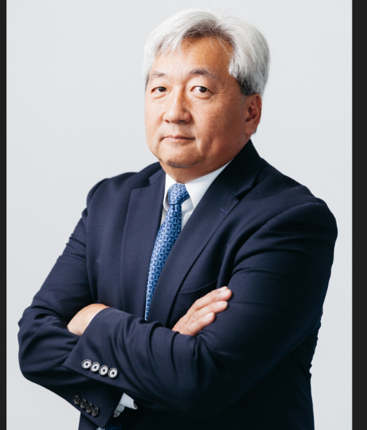
Dr. Daniel Chung is the Chief Medical Officer for SparingVision, an ocular genomic medicine company, focusing on gene agnostic therapy and CRISPR gene editing approaches to combat blinding diseases. Prior to his recruitment to SparingVision, Dr. Chung was the Ophthalmology Therapeutic Leader for Spark Therapeutics, where he led the medical affair group and contributed to areas of clinical development and operations, marketing, patient advocacy, pre-clinical research, and business development. Dr. Chung was intimately involved with the development of Luxturna, the first gene therapy approved by the FDA and EMA for use in a blinding genetic disease (RPE65).

Prior to joining Spark Therapeutics, at the Scheie Eye Institute, University of Pennsylvania, Dr. Chung worked in retinal gene therapy. Also serving as a sub-PI on the RPE65 gene therapy clinical trial at the Children’s Hospital of Philadelphia (CHOP), and made major contribution to the development of the Phase 3 multi-luminance mobility test (MLMT) novel endpoint. He was also part of the MLMT study, and the RPE65 Natural History Study. He completed his ophthalmology residency at Summa Health Systems in Akron, Ohio, and completed fellowships in pediatric ophthalmology and ocular genetic research at the Cole Eye Institute at the Cleveland Clinic, and in retinal gene therapy at the National Eye Institute in Bethesda, Maryland.

Support View Point
Now more than ever, we need your support! View Point is free of charge for all participants. If you would like to support this program and the important sight-saving research funded by Fighting Blindness Canada, please make a donation today!

FBC Health Information Line
Our Health Information Line provides the vision loss community with someone to ask their vision health questions. If you have questions about your eye health, please call 1-888-626-2995 or email healthinfo@fightingblindness.ca

THANK YOU TO OUR VIEW POINT SPONSORS
